STUDY DESCRIPTION AR-3
Benthic Macroinvertebrate Sampling in Project-affected Reaches
Draft – May 2026

This Study Description was developed to inform information gaps identified by Calaveras County Water District (CCWD) for the relicensing of its North Fork Stanislaus River Hydroelectric Project (Project).

STUDY AREA

For the purposes of this study, the Study Area includes the North Fork Stanislaus River from the North Fork Diversion Dam and Impoundment downstream to its confluence with the Middle Fork Stanislaus River, the Stanislaus River where it originates at the confluence of the Middle Fork and North Fork Stanislaus rivers downstream to Collierville Powerhouse, Highland Creek from New Spicer Meadow Reservoir down to its confluence with the North Fork Stanislaus River, and Beaver Creek from Beaver Creek Diversion Dam and Impoundment to the confluence with the North Fork Stanislaus.

Sampling Locations

General sampling locations are identified in Figure 1 and listed in Table 1. Sites were selected that are distributed across the river’s major geomorphic reaches while also ensuring safe and practical access. At each sampling site (Figure 1 and Table 1), representative riffle, run, and pool habitat sampling units will be sampled when possible and exact sample reaches will be designated per the State Water Resources Control Board’s Surface Water Ambient Monitoring Program (SWAMP) protocol (Ode et al. 2025).
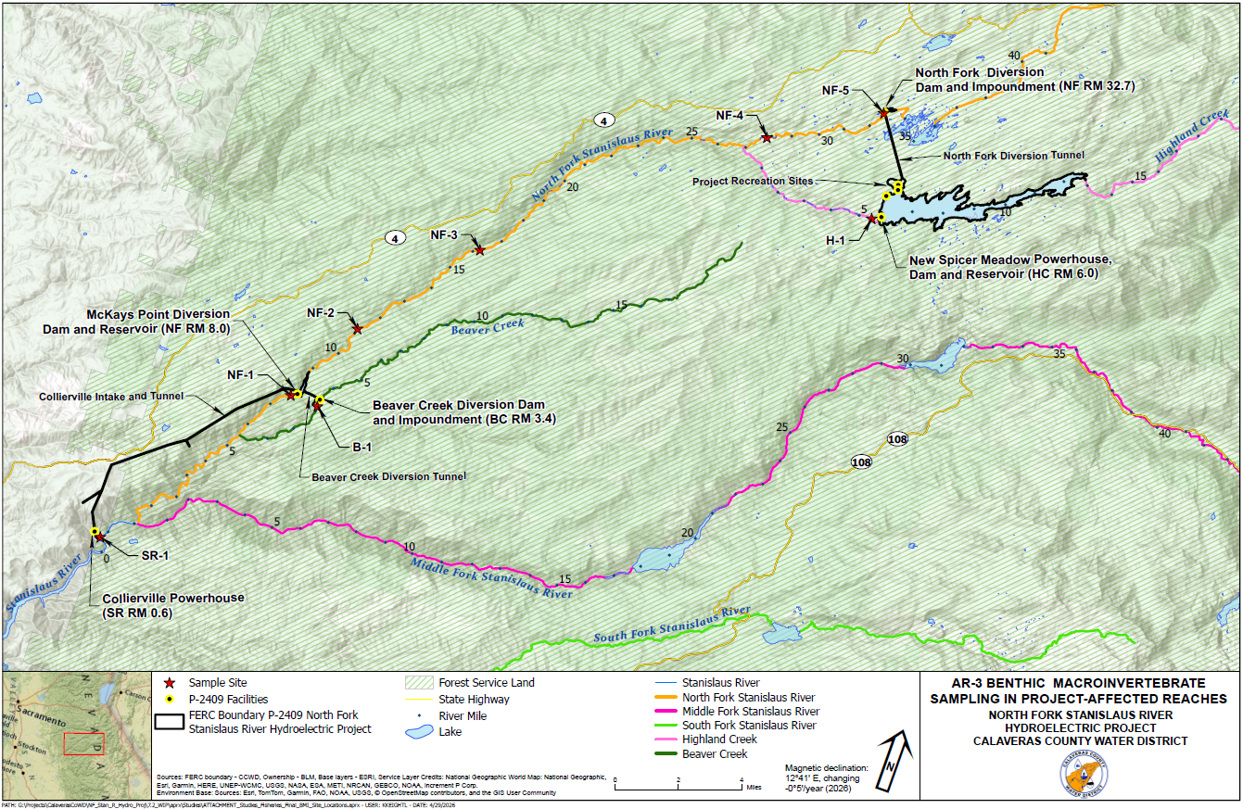
Figure 1. Map of North Fork Stanislaus River Hydroelectric Project AR-3Sampling Sites.
Table 1. Summary Information of North Fork Stanislaus River Hydroelectric Project BMI Sampling Sites.
River | Site Name | Site Description | Approximate River Mile
Stanislaus River¹ | SR-1 | Upstream of Collierville Powerhouse | SR 0.7
North Fork Stanislaus River¹ | NF-1 | Downstream of McKays Diversion Dam | NF 7.7
North Fork Stanislaus River¹ | NF-2 | Stanislaus River Day Use Area | NF 11.2
North Fork Stanislaus River¹ | NF-3 | Wakalu Hep Yo Campground | NF 16.2
North Fork Stanislaus River¹ | NF-4 | Pioneer Walking Bridge | NF 27.8
North Fork Stanislaus River¹ | NF-5 | Downstream of North Fork Diversion Dam | NF 32.7
Beaver Creek | B-1 | Downstream of Beaver Creek Diversion Dam | BC 3.0
Highland Creek | H-1 | Downstream of New Spicer Meadows Dam | HC 5.5
¹ River Miles start at New Melones Reservoir high water mark on the mainstem Stanislaus and continue as the same series into the North Fork Stanislaus.

STUDY METHODS

Field Methods

CCWD will use SWAMP methods for consistency of methodology with generally accepted scientific practices. This study is conditional on measures contained within the California Department of Fish and Wildlife (CDFW) scientific collecting permit, which will be obtained prior to sampling. Study methods described below that are unsupported by permits may not be implemented.
Reach Set Up

Sampling methods will conform to the standard reach wide benthos (RWB) methods for documenting and describing BMI assemblages and physical habitat described by the SWRCB’s SWAMP in 2025 (Ode et al. 2025). If the site’s average wetted width is ≤ 10 meters (m), the reach will be 150 m in length and 250 m if the width is greater than 10m. The standard sampling layout consists of 11 “main” transects (A-K) interspersed with 10 “inter-transects”, all of which are arranged perpendicularly to the primary direction of stream flow (usually the thalweg), and placed at equal distances from one to the next. The first flag should be installed at water’s edge on one bank at the downstream limit of the sampling reach to indicate the first main transect (“A”). The positions of the remaining transects and inter-transects are then established by heading upstream along the bank and using the transect tape or a segment of rope of appropriate length to measure off successive segments of 7.5 m (if sampling reach is 150 m), or 12.5 m (if it is 250 m).

Physical Habitat and Water Chemistry

Physical habitat and water quality will be characterized at each site. The habitat scoring criteria outlined by the SWAMP provides an effective measure of the physical integrity of a stream. The following list of quantitative measures of chemical and physical/habitat characteristics will be collected at each site:
- Reach-wide Parameters
  - GPS coordinates will be recorded at the top and bottom of the site
  - Water temperature, specific conductance, pH, and dissolved oxygen will be measured using approved standardized procedures and instruments
  - Total reach length and gradient (percent slope) as well as average width and depth will be recorded
  - Take photographs at the top, middle and bottom of the reach
  - A flow measurement will be taken within the reach
- Transect-specific Parameters
  - The wetted and bankfull widths of each transect will be taken.
  - Substrate size, depth, and coarse particulate matter will be recorded at five locations along each transect.
  - Record cobble embeddedness for each cobble identified along the transects. If 25 cobbles are not recorded, supplement the data by collecting “random” cobbles within the reach.
  - Algal and macrophyte cover will be recorded at each of the sampling points.
  - Bank stability, riparian vegetation, human influences, and instream habitat complexity will be recorded.
  - Record stream shading using a densiometer.
BMI Field Collection

Samples will be collected at the 11 “main” transects by rubbing cobble and boulder substrates and disturbing finer substrate upstream of a D-frame kicknet fitted with a 0.02-inch (in.) diameter mesh net. For the RWB method, the sub-sampling position alternates between left, center, and right portions of the main transects, as one proceeds upstream from one transect to the next. These sampling locations are defined as the points at 25% (“left”), 50% (“center”) and 75% (“right”) across the wetted width in most systems. The subsamples will be combined in a jar, preserved with 95% ethanol, and labeled to form a single composite sample for that study site.
BMI Laboratory Process
BMI samples will be processed by a SWAMP certified lab per the methods outlined in the protocol (Ode et al. 2025).
Each composite sample will be rinsed in a standard no. 35 sieve (0.5 mm) and transferred to a tray with thirty, 2-3/8 inch square grids for subsampling. Subsampling will be performed using a stereomicroscope with magnifications of 10 to 20 times magnification.
Subsamples will be transferred from randomly selected grids to Petri dishes where the aquatic macroinvertebrates will be removed indiscriminately with the aid of a stereomicroscope and placed in vials containing 70 percent ethanol and 2 percent glycerol. In cases where aquatic macroinvertebrates abundance exceeds 100 organisms per grid, half grids will be delineated to assure that a minimum of three discreet areas within the tray of benthic material will be subsampled. At least 100 aquatic macroinvertebrates will be subsampled from a minimum of five grids, or five half grids.
The debris from the processed grids will be placed in a remnant jar and preserved in 70 percent ethanol for later quality control testing. Subsampled aquatic macroinvertebrates will be identified by a taxonomist approved by the California Department of Fish and Wildlife (CDFW) for U.S. Environmental Protection Agency (USEPA) evaluations using standard aquatic macroinvertebrate identification keys (e.g., Kathman and Brinkhurst 1999, Merritt and Cummins 1996, Stewart and Stark 1993, Thorp and Covich 2001, Wiggins 1996) and other appropriate references.
All organisms retained on a 0.5-mm screen will be removed from the subsample and a standard level 2a taxonomic effort will be used as specified in the Southwestern Association of Freshwater Invertebrate Taxonomists (SAFIT) in 2015 (Richards and Rogers 2011).
Analysis

Analytical methods will conform to the standard methods describing BMI assemblages and physical habitat outlined by SWAMP. Standard biological metrics, plus additional relevant metrics, will be calculated for each site (Table 2) and presented in graphical or tabular form.

Table 2. Biological metrics calculated to assess BMI assemblages
BMI Metrics | Description
 | RICHNESS MEASURES
Taxonomic Richness | Total number of individual taxa
No. EPT Taxa | Number of taxa in the insect orders Ephemeroptera, Plecoptera, and Trichoptera
Ephemeroptera Taxa | Number of mayfly taxa
Plecoptera Taxa | Number of stonefly taxa
Trichoptera Taxa | Number of caddisfly taxa
Coleoptera Taxa | Number of beetle taxa
% EPT | Percent of the composite of mayfly, stonefly, and caddisfly larvae
% Ephemeroptera | Percent of mayfly nymphs
Shannon Diversity Index | General measure of sample diversity that incorporates richness and evenness
California Tolerance Value (CTV) | CTVs between 0 and 10 weighed for abundance of individuals designated as pollution tolerant (higher values) and intolerant (lower values)
No. of Intolerant taxa | Taxa richness of those organisms considered to be sensitive to perturbation
% Tolerant Organisms | Percent of macrobenthos considered to be tolerant of various types of perturbation
% Dominant Taxon | Measures the dominance of the single most abundant taxon. Can be calculated as dominant 2, 3, 4, or 5 taxa
 | FEEDING MEASURES
% CF+CG Individuals | Percentage of BMIs within the collector-filterer and collector gatherer functional feeding groups
% Scrapers | Percent of macroinvertebrates that graze upon periphyton
% Non-gastropoda Scrapers | Percentage of BMIs within the scraper functional feeding group excluding gastropod scrapers
% Predators | Percent of macroinvertebrates that prey on living organisms
% Shredders | Percent of macroinvertebrates that shred leaf litter

The results from each site will be scored utilizing the California Stream Condition Index (CSCI) to translate BMI metrics into a measure of overall stream health (Rehn et al. 2015).
Following data collection and identification of taxa, CCWD will subject all data to quality assurance/quality control (QA/QC) procedures including, but not limited to, spot-checks of data and review of electronic data for completeness. If any datum seems inconsistent, CCWD will investigate the problem.
REPORTING

This Study will generate the tables and plots described above as relevant to the SWAMP protocol including biological and habitat metrics.

SCHEDULE

CCWD anticipates the schedule for Study completion as follows:

Conduct Field Surveys Late August – October 2027
BMI Laboratory Processing November – January 2028
Reporting February – March 2028

REFERENCES

Kathman, R.D., and R.O. Brinkhurst. 1999. Guide to the freshwater oligochaetes of North America. Aquatic Resources Center, College Grove, TN. 264 pp. Available online at: https://cir.nii.ac.jp/crid/1970867909804926507.
Merritt, R.W., and K.W. Cummins (eds.). 1996. 3rd Edition. An Introduction to the Aquatic Insects of North America. Kendall and Hunt Publishing Co., Dubuque, IA. Available online at: https://books.google.com/books?hl=en&lr=&id=UUtEoRejk0AC&oi=fnd&pg=PP17&dq=Merritt,+R.W.+and+K.W.+Cummins+(eds.).++1996.++3rd+Edition.+An+Introduction+to+the+Aquatic+Insects+of+North+America.+Kendall+and+Hunt+Publishing+Co.,+Dubuque,+IA.&ots=f2ZHyXKVZu&sig=54NINQTiNW4Qx3FtwuxAEr8V2YQ#v=onepage&q&f=false.
Ode, P.R., A.E., Fetscher, L. Busse, A. Furler, C. Loflen., N. Mack, R.D. Mazor, S. McBride, D. Pickard, A.C. Rehn, and S. Theroux. 2025. Standard Operating Procedures for the Collection of Field Data for Bioassessments of California Wadeable Streams: Benthic Macroinvertebrates, Algae, and Physical Habitat. California State Water Resources Control Board Surface Water Ambient Monitoring Program (SWAMP) SOP-SB-2025-0001 Available online at: https://www.waterboards.ca.gov/water_issues/programs/swamp/bioassessment/docs/2025/bioassessment-sop-2025-revision.pdf.
Rehn, A.C., R.D. Mazor and P.R. Ode. 2015. The California Stream Condition Index (CSCI): A New Statewide Biological Scoring Tool for Assessing the Health of Freshwater Streams. Swamp Technical Memorandum SWAMP-TM-2015-0002. Available online at: https://www.waterboards.ca.gov/water_issues/programs/swamp/bioassessment/docs/csci_tech_memo.pdf.
Richards, A. B., and D. C. Rogers. 2011. List of freshwater macroinvertebrate taxa from California and adjacent states including standard taxonomic effort levels. Southwest Association of Freshwater Invertebrate Taxonomists. Chico, CA. Available online at: https://safit.org/wp-content/uploads/2024/01/STE_1_March_2011_7MB.pdf.
Stewart, K.W. and B.P. Stark. 1988. Nymphs of North American Stonefly genera (Plecoptera). Monograph 12. Thomas Say Foundation. 460 pp.
Thorp, A.P. and A.P. Covich (eds.) 1991. Ecology and Classification of North American Freshwater Invertebrates. Academic Press, Inc., San Diego, CA.
Wiggins, G.B. 1996. Larvae of the North American Caddisfly Genera (Trichoptera). 2nd ed. Univ. Toronto Press, Canada. Available online at: https://archive.org/details/larvaeofnorthame0000wigg/page/n5/mode/2up.

In addition to the details provided in this study description, study implementation will also follow the "Concepts and Practices Applicable to All Relicensing Studies" developed by CCWD.
In addition to the details provided in this section, reporting will also follow the "Concepts and Practices Applicable to All Relicensing Studies" developed by CCWD.

