STUDY DESCRIPTION TR-1
Botanical Resources Study including Vegetation Mapping and
Protocol Surveys for Special-Status Species and Non-Native Invasive Plants

Draft – April 1, 2026

This Study Description is developed to inform information gaps identified by Calaveras County Water District (CCWD) for the relicensing of its North Fork Stanislaus River Hydroelectric Project (Project).

STUDY AREA

The Study Area includes all areas within the Federal Energy Regulatory Commission (FERC) Project boundary plus a 20-foot buffer around the boundary with the following exceptions: 1) boundaries for underground Project facilities (i.e., tunnels) are not included in the Study Area; 2) at Spicer Meadows Reservoir, the Study Area includes the boundary encompassing the powerhouses, dam, other Project facilities, and recreation areas plus a 20 foot buffer (i.e., these are areas where routine ground disturbing activities may occur) and the area within the New Spicer Meadows Reservoir normal maximum water surface elevation (NMWSE) plus a 50 foot buffer area; and 3) at McKays Reservoir, the Study Area includes the boundary encompassing the dam plus a 20 foot buffer and the area within the McKays Dam NMWSE plus a 50 foot buffer area. Figures TR1-1 and TR 1-2 show the Study Area. This results in a Study Area of approximately 1,400 acres, minus those areas that will be inundated at the time the surveys are conducted. The Study Area ranges in elevation between 1,086 feet and 6,766 feet.

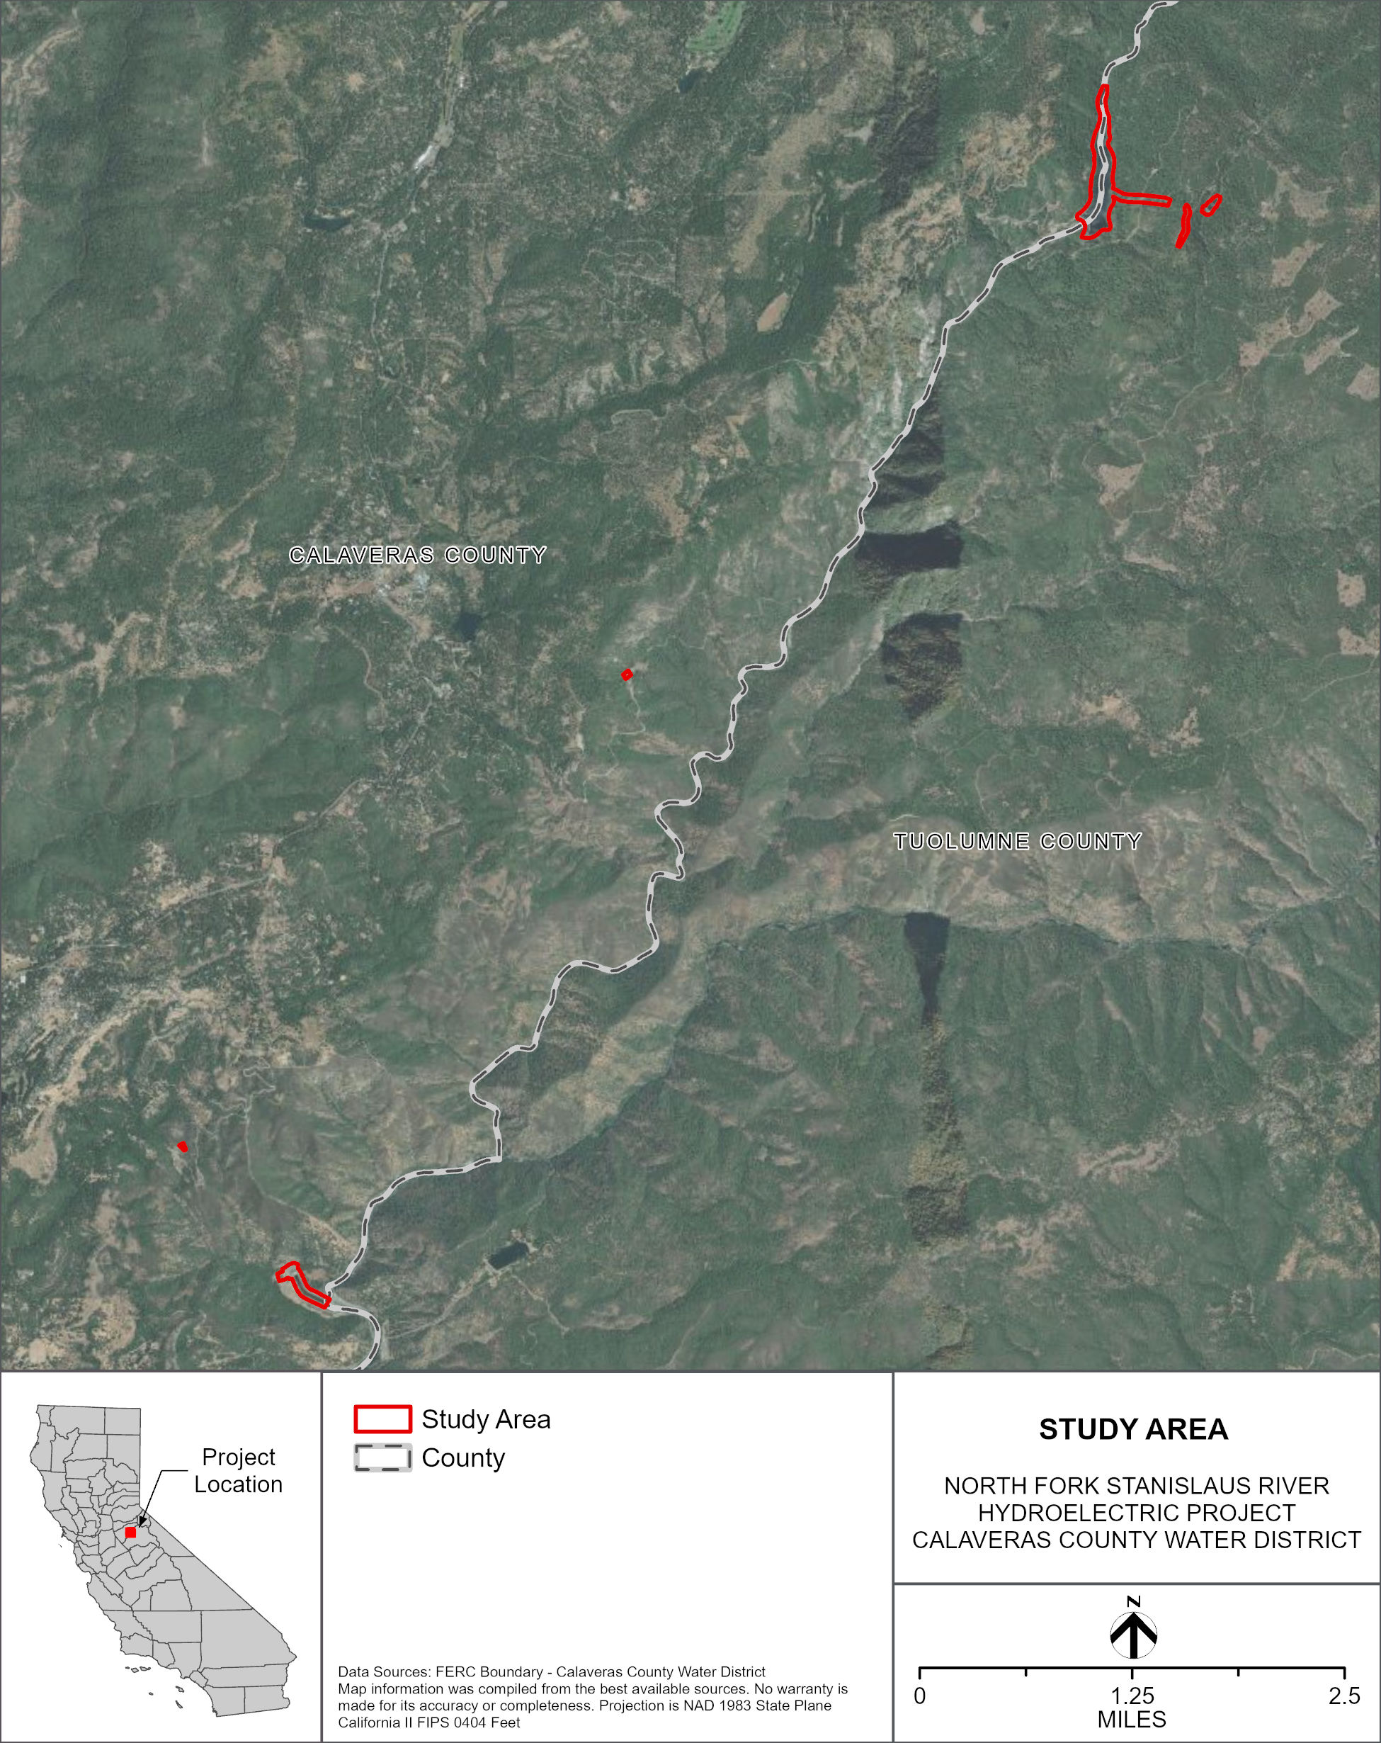
Figure TR 1-1. Study Area (McKays Dam & Collierville Tunnel & Beaver Creek Portion).
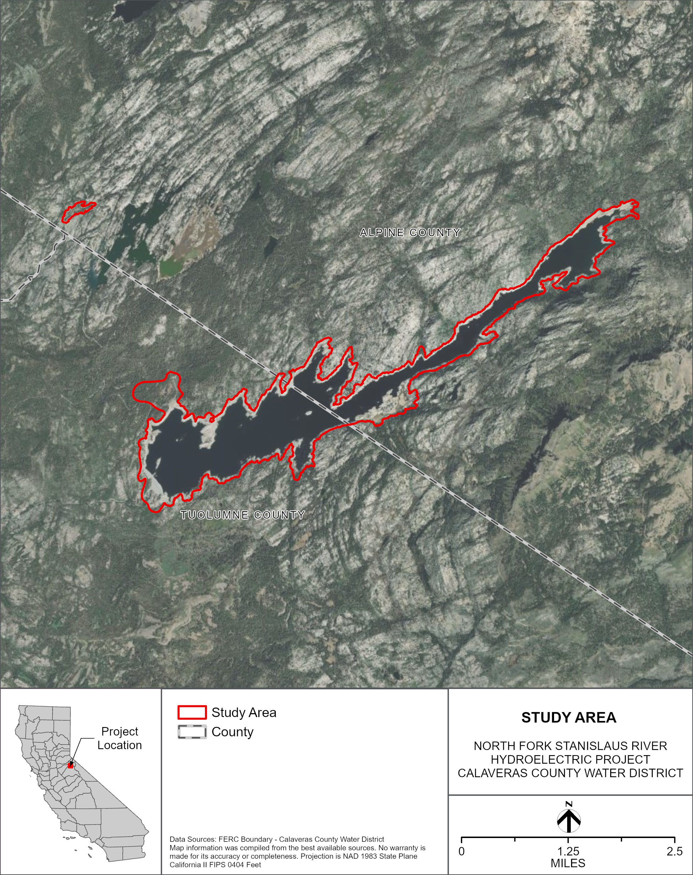
Figure TR 1-2. Study Area (New Spicer Reservoir & North Fork Diversion Dam Portion).
For this Study description the following definitions apply:

Special-Status Botanical Species
- Is a species and, at the time the study is conducted, is;
  - Listed as Threatened or Endangered, or is a candidate or proposed for listing under the federal Endangered Species Act (USFWS 2026) and/or;
  - Listed as Threatened, Endangered, or Rare or is a candidate for listing under the California Endangered Species Act (CDFW 2026a) and/or;
  - Listed as a United States Department of the Interior, Bureau of Land Management (BLM) Sensitive species and occurs on lands administered by BLM (BLM 2026) and/or;
  - A plant that is listed by the United States Department of Agriculture, Forest Service (Forest Service) as a Forest Service Sensitive Species or a Stanislaus National Forest (STF) Watch List species and occurs on National Forest System (NFS) lands (STF 2026); and/or
  - Listed by the California Native Plant Society as a Rare Plant with a Rank of 1B (Rare, Threatened, or Endangered Throughout Its Range) or 2B (Rare, Threatened, or Endangered in California, But Common Elsewhere) (CNPS 2026a).
  - Species of milkweed in the genus Asclepias, which are the only food source for monarch butterfly (Danaus plexippus) caterpillars.

Non-Native Invasive Plant (NNIP)
- Occurs as a discreet occurrence or cluster of occurrences that cumulatively cover less than 1 acre of the Study Area and is;
  - Listed by the California Department of Food and Agriculture (CDFA) with a rating of A (pest of known economic or environmental detriment and is either not known to be established in California or it is present in a limited distribution that allows for the possibility of eradication or successful containment) or B (pest of known economic or environmental detriment and, if present in California, it is of limited distribution) (CDFA 2021) and/or;
  - Listed by the STF on its priority 1 invasive plant list (STF 2026) and is on NFS lands, as well as priority 2 species in certain circumstances, such as the species presence in the study area being co-located with a special-status plant occurrence and/or;
  - Listed by the California Invasive Plant Council (Cal-IPC) with a Weed Rating of High (species with severe ecological impacts on physical processes, plant and animal communities, and vegetation structure) Moderate (species have substantial and apparent—but generally not severe—ecological impacts on the surrounding habitat. They have moderate to high rates of dispersal. Distribution may range from limited to widespread) or Watch List (These species are predicted to become invasive if no further actions are taken. Distribution may range from limited to widespread in specific regions) (Cal-IPC 2026).

Additionally if a CDFA rated C species (If found in the state, they are subject to regulations designed to retard spread or to suppress at the discretion of the individual county agricultural commissioner) (CDFA 2021) is found in immediate proximity to a special-status botanical species occurrence it will be noted in the metadata collected for that occurrence.

Special status plants and NNIP collectively will hereafter in this study description be referred to as Target Species.

STUDY METHODS

Excluding Data Summary Development (i.e., Reporting), the Study consists of the following four steps: 1) Conduct Desktop Review; 2) Conduct Floristic Field Survey; 3) Prepare Vegetation Map; and 4) Analysis. Each step is described below.

Step 1 – Conduct Desktop Review

CCWD will compile a list of special-status plant species with potential to occur in the Study Area starting with the information from CCWD’s Project Pre-Application Document, or PAD (CCWD 2026) and updated by querying the following:

- United States Department of the Interior, Fish and Wildlife Service’s (USFWS) Information for Planning and Consultation portal (USFWS 2026);
- California Department of Fish and Wildlife’s (CDFW) California Natural Diversity Database (CNDDB) (CDFW 2026b);
- California Native Plant Society’s online Inventory of Rare and Endangered Plants of California (California Native Plant Society 2026);
- STF’s updated list of Threatened, Endangered, Sensitive, and Watch List Plants (Forest Service 2026); and
- BLM’s updated list of Sensitive Species (BLM 2026).

The primary purpose of this list of special-status plant species is to direct the timing of surveys being conducted in the Study Area, so that surveyors have the greatest likelihood of detecting special-status species with potential to occur in the Study Area. All special-status botanical species, as defined, located during surveys will be recorded. Should a list of culturally significant plants for relicensing be provided by Native American Tribe(s) (developed under Study CR-2), information on the culturally significant plants will be compiled and used to inform field studies and reporting needs.

With respect to NNIP, CCWD will compile a list of potential NNIP species using CCWD’s PAD (CCWD 2026) as well as the most current CDFA list of noxious weeds (CDFA 2021), STF’s Invasive Plant List (Forest Service 2026), and the list of Cal-IPC ranked High and Moderate species known to occur in the upper Stanislaus River watershed (Cal-IPC 2026). This list is also intended to direct the timing of surveys.

Step 2 – Conduct Floristic Field Survey

CCWD’s surveyors will generally conduct surveys for special-status botanical species, NNIP species, and vegetation community/habitat mapping as outlined in the CDFW’s Protocols for Surveying and Evaluating Impacts to Special Status Native Plant Populations and Sensitive Natural Communities (CDFW 2018). This protocol comprehensively covers all land types in the study area that are safe to access (Forest Service, BLM, and private) and includes the same guidelines and provisions for data collection and survey intensity as the BLM Survey Protocols Required for NEPA/ESA Compliance for BLM Special Status Plant Species (BLM 2009) as well as the Forest Service Handbook 2609.26, Chapter 10 (Forest Service 2020), while also providing information requested by CDFW.

Furthermore, as outlined in Forest Service Handbook 2609.26, Chapter 10;
- Lead surveyors will obtain a voucher collection permit from the Forest Service prior to surveys being conducted. Any voucher collection will be conducted by or under the direct supervision of a lead surveyor following Forest Service guidelines.
- Voucher specimens of vascular plants will be deposited at the University of California, Davis herbarium, voucher specimens of lichens will be deposited at the Jepson Herbarium, voucher specimens of bryophyte species will be deposited at the Jepson herbarium or San Jose State University herbarium. All voucher collection data will be shared with the Forest Service botanist.
- CCWD will request from the Forest Service appropriate occurrence codes for any special-status plant species found as outlined in Section 12 of Forest Service Handbook 2609.26, Chapter 10.

For vascular plant species, the surveys will be floristic in nature in that all vascular species observed will be fully identified to the lowest possible rank based on the plants’ available anatomy. Scientific and common names for those species that are considered special status will conform to the nomenclature found in CDFW’s Special Vascular Plants, Bryophytes, and Lichens List (CDFW 2026b) while all other species’ scientific names will conform to the nomenclature found on the Jepson eFlora (Jepson Flora Project 2026). Other species’ common names will conform to the nomenclature found on the Jepson eFlora.

The Study Area will be surveyed twice with all surveys tentatively scheduled to occur between April and September. This time range is based on the elevation range of the two primary components of the Study Area as depicted in Figures TR 1-1 and 1-2, the mixture of special-status botanical species and NNIP species with potential to occur and their phenology ranges when they are most identifiable, and as of yet unknown weather conditions for the survey year which can shift survey timing. The timing will ultimately be set to survey when all special-status plant species and NNIP species with potential to occur in the study area are detectable. This timing will also include the ability to map all vegetation types and habitats in the study area as well. Any special status botanical species and NNIP species, as well as special habitats such as lava caps, meadows, rocky outcroppings, aquatic features, large riparian areas will be mapped when observed.

Non-vascular special-status botanical species surveys will also be conducted in the same manner as vascular species surveys with the following deviations:

- Surveys for bryophytes may need to begin in March for lower elevation portions of the study area based on weather conditions.
- As identified in the PAD, one species of special-status lichen has potential to occur in the study area. Two additional lichen species are designated as watch list by the STF (STF 2026). If any lichen species are found that resemble these three lichen species, they will be mapped as if they are special-status botanical species. Voucher samples will be collected if the population is of sufficient size to allow collecting, and these samples will be sent to the Jepson Herbarium for expert verification. If expert verification determines that the collected samples are not a special-status lichen species, these data will not be included in the study report. If expert verification determines that the collected samples are a special-status lichen species, these data will be included in the study report. Voucher collection information of any lichen species will be shared with the Forest Service regardless of what species they are verified to be.

Special-Status Botanical Species

If special-status botanical occurrences are located in the Study Area, the following information will be collected:

- Digital photographs (both large and small scale) showing the species and its habitat (one set only per taxa);
- Any special-status botanical species found in the Study Area will be mapped with a polygon.
- Ecological information sufficient to fill out a CNDDB form will be collected at the time of survey, except for species of milkweed in the genus Asclepias which do not have a California Rare Plant Rank nor are listed by the STF or BLM as sensitive or watch list. Such species of milkweed will only have metadata for species and population size collected.

NNIP

If NNIP occurrences are found in the Study Area, surveyors will collect the following data to the edge of the occurrence or to the edge of the Study Area if the occurrence goes beyond it:

- Digital photographs depicting the species and its habitat (one set only per species);
- Any NNIP species found in the study area will be mapped with a polygon. Metadata to be collected at the time of survey will include location and plant population estimated size. In instances where one polygon represents multiple co-occurring NNIP species, each species in the polygon and their respective population size will be recorded in the metadata.

Step 3 – Prepare Vegetation Map

Vegetation types and other habitats will be mapped covering the Study Area. Where vegetation overlaps with another type of mapping unit, such as a tree canopy over water or roads, the area will be mapped according to the uppermost layer of vegetation. A minimum mapping unit of 0.1 acre will be used when differentiating vegetation types and other habitats. Some vegetation types and other habitats may be mapped below the level of 0.1 acre, such as vegetation types typically associated with wetland features, at the discretion of the surveyors. Vegetation mapping will occur concurrently with surveys for target species. Vegetation mapping will not require surveyors to physically access each mapped polygon but be mapped from appropriate vantage points to view the Study Area.

For each vegetation type or other habitat observed in the field, species composition and percent cover will be recorded on vegetation mapping forms. Nomenclature of vegetation types will follow that of the Manual of California Vegetation Online (CNPS 2026b) to allow for importing into CDFW’s Vegetation Classification and Mapping Program (CDFW 2025) as a requirement to the Protocols for Surveying and Evaluating Impacts to Special Status Native Plant Populations and Sensitive Natural Communities (CDFW 2018). If a vegetation type is recorded that does not conform to a described vegetation type, a new name will be created conforming to the general format of the Manual of California Vegetation Online (CNPS 2026b). These vegetation and other habitat layers will be used to inform components of Study TR-3, as it can be imported into the California Wildlife Habitat Relationships (CWHR) model.

Step 4 - Analysis

Analysis of Target Species data will consist of reviewing field forms and comparing them and GIS datasets to verify that all required data are recorded and there are no data gaps. Plant species unable to be confidently identified in the field will have pictures or samples reviewed and identified. If necessary, CCWD will use the herbarium at the University of California Davis to compare samples and pictures with expertly identified voucher samples.

Vegetation data will be reviewed with the Manual of California Vegetation Online (CNPS 2026b) to assign labels to each vegetation type mapped in the field. Other habitat types will be named based on their primary component, such as lava cap or developed land. Field maps will be digitized to complete a final vegetation layer for the Project. All Project photographs taken in the field and intended for inclusion in future reporting will be catalogued and labeled for future use.

REPORTING

This Study will create shapefiles of special-status botanical and NNIP occurrences as well as special habitats and all other vegetation and habitat types within the Study Area. CNDDB survey forms will also be completed. GIS shapefiles and CNDDB survey forms of botanical data will be shared with the Forest Service.

SCHEDULE

CCWD anticipates the schedule for Study completion as follows:

Conduct Desktop Review January – March 2027
Conduct Floristic Field Survey March – September 2027
Prepare Vegetation Map April – September 2027
Analysis August – September 2027
Data Summary Development September – November 2027

REFERENCES

Calaveras County Water District (CCWD). 2026. North Fork Stanislaus River Hydroelectric Project FERC Project No. 2409 Pre-Application Document (PAD) Volume 1. Prepared by HDR.
California Department of Fish and Wildlife (CDFW). 2018. Protocols for Surveying and Evaluating Impacts to Special Status Native Plant Populations and Sensitive Natural Communities. CDFW, Natural Heritage Division, Sacramento, CA. Available online at: https://wildlife.ca.gov/Conservation/Survey-Protocols#377281280-plants.
_____. 2025. “Vegetation Classification and Mapping Program (VegCAMP).” Natural Heritage Division, Sacramento. Available online at: https://wildlife.ca.gov/Data/VegCAMP.

_____. 2026a. “Special Vascular Plants, Bryophytes, and Lichens List.” Natural Heritage Division, Sacramento, California. Available online at: https://www.wildlife.ca.gov/Data/CNDDB/Plants-and-Animals.
_____. 2026b. “California Natural Diversity Database Maps and Data.” California Natural Diversity Database: Rarefind 5, records of occurrence. Natural Heritage Division, Sacramento. Available online at: https://www.wildlife.ca.gov/Data/CNDDB/Maps-and-Data.

California Department of Food and Agriculture (CDFA). 2021. “CDFA Weed Pest Ratings and CCR 4500 Noxious Weeds.” Last updated June 22, 2021. Available online at: https://www.cdfa.ca.gov/plant/ipc/encycloweedia/pdf/CaliforniaNoxiousWeeds.pdf.
California Invasive Plant Council (Cal-IPC). 2026. “California Invasive Plant Inventory Database.” Berkeley. Available online at: http://cal-ipc.org/ip/inventory/index.php/.
California Native Plant Society. 2026a. “CNPS Rare Plant Inventory.” Inventory of rare and endangered vascular plants of California. (Online Edition, v9.5.1). Sacramento. Available online at: http://www.rareplants.cnps.org/.
_______. 2026b. A Manual of California Vegetation Online. Available online at: https://vegetation.cnps.org/.
Jepson Flora Project. 2026. “Jepson eFlora” (Revision 14). University of California, Berkeley. Last updated March 12, 2026. Available online at: http://ucjeps.berkeley.edu/IJM.html.
Stanislaus National Forest (StF). 2026. Information on Forest Service Sensitive, Watch List, and Invasive species for the Stanislaus National Forest. Transmitted by SNF on January 12, 2026.
United States Department of Agriculture, Forest Service (Forest Service). 2020. Forest Service Handbook 2609.26, Chapter 10, Sensitive Plant Program Management. Pacific Southwest Region (R5). Available online at: https://www.fs.usda.gov/im/directives/field/r5/fsh/2609.26/R5-2609-26-Contents-2020-1%203a.pdf.
____, Stanislaus National Forest (STF). 2026. Information on Forest Service Sensitive, Watch List, and Invasive species for the Stanislaus National Forest. Transmitted by Stanislaus National Forest on January 12, 2026.
United States Department of the Interior, Bureau of Land Management (BLM). 2009. Survey Protocols Required for NEPA/ESA Compliance for BLM Special Status Plant Species. Bureau of Land Management California State Office. Geographic Services.
_______. 2026. Information on BLM Sensitive species for California. Transmitted by BLM on January 15, 2026.
United States Fish and Wildlife Service (USFWS). 2026. Information for Planning and Consultation. Environmental Conservation Online System. Available online at: https://ecos.fws.gov/ecp/. United States Fish and Wildlife Service. Washington D.C.

In addition to the details provided in this study description, study implementation will also follow the "Concepts and Practices Applicable to All Relicensing Studies" developed by CCWD.
CNDDB forms will be completed if monarch butterflies are located.
In addition to the details provided in this section, reporting will also follow the "Concepts and Practices Applicable to All Relicensing Studies" developed by CCWD.
The timing for the field surveys is based on the range of elevation range of the study area and the phenology of target species within the study area

