STUDY DESCRIPTION AR-2
Fish Sampling in Project-affected Reaches
Draft – May 2026

This Study Description was developed to inform information gaps identified by Calaveras County Water District (CCWD) for the relicensing of its North Fork Stanislaus River Hydroelectric Project (Project).

STUDY AREA

For the purposes of this study, the Study Area includes the North Fork Stanislaus River from the North Fork Diversion Dam downstream to its confluence with the Middle Fork Stanislaus River, the Stanislaus River where it originates at the confluence of the Middle Fork and North Fork Stanislaus rivers downstream to the New Melones Reservoir high water mark, Highland Creek from New Spicer Meadow Reservoir down to its confluence with the North Fork Stanislaus River, and Beaver Creek from Beaver Creek Diversion Dam to the confluence with the North Fork Stanislaus River.

Sampling Locations

General sampling locations are identified in Figure 1 and listed in Table 2. Sites were selected that are distributed across the river’s major geomorphic reaches while also ensuring safe and practical access. At each sampling site (Figure 1 and Table 1), representative riffle, run, and pool habitat sampling units will be sampled when possible.

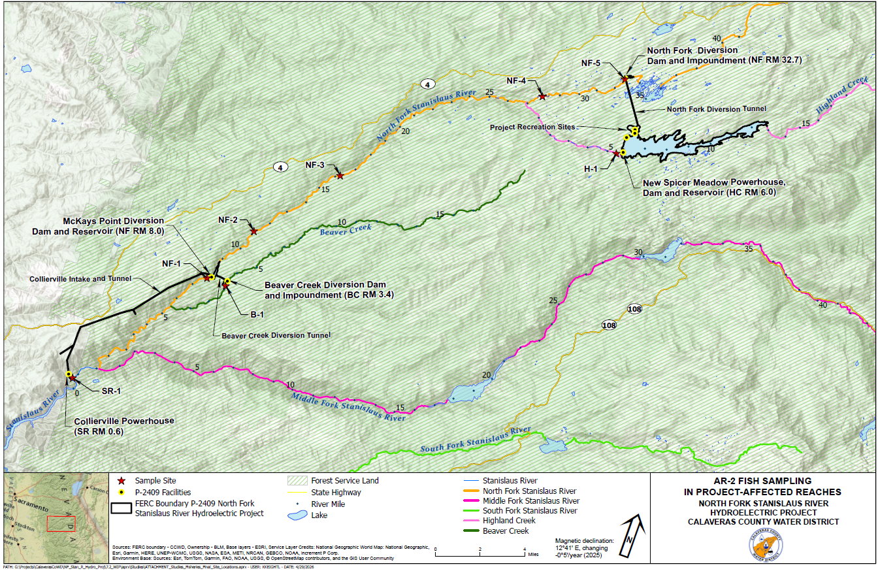
Figure 1. North Fork Stanislaus River Hydroelectric Project AR-2 Sampling Sites.
Table 1. Summary Information of North Fork Stanislaus River Hydroelectric Project Fish Sampling Sites.
River | Site Name | Site Description | Approximate River Mile
Stanislaus River¹ | SR-1 | Upstream of Collierville Powerhouse | SR 0.7
North Fork Stanislaus River¹ | NF-1 | Downstream of McKays Diversion Dam | NF 7.7
North Fork Stanislaus River¹ | NF-2 | Stanislaus River Day Use Area | NF 11.2
North Fork Stanislaus River¹ | NF-3 | Wakalu Hep Yo Campground | NF 16.2
North Fork Stanislaus River¹ | NF-4 | Pioneer Walking Bridge | NF 27.8
North Fork Stanislaus River¹ | NF-5 | Downstream of North Fork Diversion Dam | NF 32.7
Beaver Creek | B-1 | Downstream of Beaver Creek Diversion Dam | BC 3.0
Highland Creek | H-1 | Downstream of New Spicer Meadows Dam | HC 5.5
¹ River Miles start at New Melones Reservoir high water mark on the mainstem Stanislaus and continue as the same series into the North Fork Stanislaus.

STUDY METHODS

Field Methods

A combination of electrofishing and/or snorkeling at each sample site will be conducted to collect fish data. Electrofishing will generally be used in riffle habitats and shallow runs, while snorkeling will be used in reaches with unsafe electrofishing conditions including deeper water (e.g., pools), swift currents, or other hazards. A minimum of 100 feet of each habitat type will be sampled when possible. When snorkeling in deeper units, unit lengths within a sample site may be significantly longer than 100 feet to accommodate natural hydrologic breaks. This study is conditional on measures contained within the California Department of Fish and Wildlife (CDFW) scientific collecting permit and USFWS 10(a)1(a) permit, which will be obtained prior to sampling. Study methods described below that are unsupported by permits may not be implemented.

In addition to these methods, eDNA metabarcoding will be conducted as a secondary measure of species composition. This will potentially allow for detection of more cryptic species and will sample water coming from areas upstream of selected sample sites, which extends the reach of the study beyond just species composition at the immediate sample sites.

Sampling Unit Habitat Measurements

Routine observations will be made of habitat and physical conditions in each sampling unit. These observations will include physical measurements of water temperature and specific conductance. Sampling unit lengths, widths, and depths will also be documented to calculate fish abundance by length and area of stream sampled. Length will be measured along the thalweg of the channel. Stream widths and depth transects will be measured at one-quarter, half, and three-quarters the length of each habitat unit. At each depth transect, depth will be measured at one-quarter, half, and three-quarters the width of the channel.

Electrofishing

For electrofishing efforts, sampling protocols will be consistent with those in Flosi et al. (2010). Multi-pass electrofishing will consist of a minimum of two electrofishing depletions with equal sampling effort. If depletions do not result in an overall fish abundance estimate with a confidence interval of approximately ±15% or less, then a third depletion, if needed, will be completed. Sample units will be sectioned off, prior to sampling, using block nets. Captured fish from each pass will be kept in separate live wells or buckets. Fish will be enumerated, identified to species, measured to fork length, and the first 20 individuals of each species will be weighed in each sampling unit. Trout origin will be identified (hatchery or wild stock) based on adipose fin clips. When sampling is completed, fish will be returned to their original habitat.

Snorkeling

For snorkeling efforts, sampling protocols will be consistent with those in Flosi et al. (2010). Sample units will be sectioned off, prior to sampling, using block nets. Snorkelers will survey in lanes along the river and identify, count, and estimate the length of each fish observed. Fish will be grouped into five size classes (0–3, 3–6, 6–9, 9-12, 12–18, and >18+ inches). Fish data will be recorded by habitat unit type. When identification is uncertain for juvenile minnows <3 inches in size (i.e., hardhead, Sacramento pikeminnow, Sacramento suckers, and/or California roach) counts will be recorded as a single category called mixed minnow. Very small salmonid fish that cannot be identified to species will be recorded as fry.

eDNA Sampling

At each of the eight sampling sites (Figure 1), eDNA samples will be obtained following Genidaqs standard protocols and using designated sampling kits for eDNA metabarcoding. An eDNA-based approach is an efficient, non-invasive method to detect fish species by analyzing DNA shed into the water, providing a comprehensive assessment of fish species present over time from a reduced number of field samples. Detailed protocols and methods are provided in Attachment A.

Analysis

Fish abundance estimates for each sampling unit, based on multi-pass depletion, will be calculated using MicroFish 3.0 (Van Deventer 2020). Data will be analyzed by fish species and, when sufficient numbers of fish are captured, size specific group estimates for a species can be determined based on an evaluation of the length-frequency distributions. For species with low sample sizes where abundance cannot be estimated, the total number of fish captured will be presented. For sample units with snorkeling surveys, total number of fish observed will serve as an index of abundance. The data will be used to summarize fish standing crop estimates for each sampling unit within each sampling site in terms of density (e.g., fish/ft² and fish/mile). Fish species composition and distribution information will be compared to known species information as presented in Section 3.4 of the Pre-Application Document. Results of the eDNA metabarcoding analysis will be provided by Genidaqs. This will include a list of detected species, along with supporting tables and figures, as applicable.

Length-weight regression plots will be developed for all species using length and weight measurements. Additionally, fish condition factors for salmonids will be calculated using measured weight and length data. Length frequency histograms by species will also be developed.

Habitat descriptions for each sampling unit will include sample locations and descriptions, a summary of measured water chemistry conditions (i.e., water temperature and conductivity), and a summary of physical measurements (i.e., unit length, width, and depth).

REPORTING

This Study will generate the tables and plots described above related to site habitat information, standing crop estimates, eDNA analysis results, fish metrics, etc.

SCHEDULE
Conduct Field Surveys Late August – October 2027
Data Analysis and Reporting November 2027 – December 2027

REFERENCES

Flosi, G., S. Downie, J. Hopelain, M. Bird, R. Coey and B. Collins. 2010. California Salmonid Steam Restoration Manual, Fourth Edition. State of California, The Resources Agency, California Department of Fish and Game, Inland Fisheries Division, Sacramento, CA. Available online at: https://nrm.dfg.ca.gov/FileHandler.ashx?DocumentID=22610&inline. Accessed on March 20, 2026.

Van Deventer, J.S. 2020. Microcomputer Software System for Generating Population Statistics from Electrofishing Data-User's Guide for MicroFish 3.0. USDA Forest Service, General Technical Report INT-254. 29 p. Original software release in 1989. Last updated November 30, 2020. Available online at: https://static1.squarespace.com/static/5d41d4393c649400019ec8c4/t/5fc554d6145a8629dc62871f/1606767832272/MicroFish3+Users+Guide.pdf. Accessed on March 20, 2026.

In addition to the details provided in this study description, study implementation will also follow the "Concepts and Practices Applicable to All Relicensing Studies" developed by CCWD.
In addition to the details provided in this section, reporting will also follow the "Concepts and Practices Applicable to All Relicensing Studies" developed by CCWD.

