STUDY DESCRIPTION AR-7
ESA-Listed Amphibian and Aquatic Reptile Visual Encounter Surveys

Draft –8/4/26

This Study Description is developed to address information gaps identified by Calaveras County Water District (CCWD) for the relicensing of its North Fork Stanislaus River Hydroelectric Project (Project).

Four federal Endangered Species Act (ESA) listed amphibian species and one aquatic reptile species proposed for ESA-listing have the potential to occur within the proposed Federal Energy Regulatory Commission (FERC) Project Boundary and/or stream reaches potentially affected by the Project, as identified in the Pre-Application Document (PAD): Yosemite toad (Anaxyrus canorus), foothill yellow-legged frog (Rana boylii; South Sierra Distinct Population Segment [DPS]), California red-legged frog (Rana draytonii), Sierra Nevada yellow-legged frog (Rana sierrae), and northwestern pond turtle (Actinemys marmorata). Two of these have been documented within the PAD’s aquatic resource Assessment Area (i.e., the FERC Project Boundary, Project-affected stream reaches, and a 0.25 mile buffer)—foothill yellow-legged frog and Sierra Nevada yellow-legged frog—while the other three have been documented outside, but within 5 miles, of the aquatic resources Assessment Area.

This study will use Visual Encounter Surveys (VES) to inform the distribution and habitat use by ESA-listed species within Project reservoirs and Project-affected reaches. This study will be conducted alongside Study AR-6 (Special-status Amphibian and Aquatic Reptile eDNA Sampling); environmental deoxyribonucleic acid (eDNA) sampling will serve to supplement this study’s findings.

STUDY AREA

The Study Area includes safely accessible areas within 0.25 mile of the proposed FERC Project Boundary, which includes the project impoundments (i.e., North Fork Diversion Dam impoundment, New Spicer Meadow Reservoir, Beaver Creek Diversion Dam impoundment, and McKays Point Reservoir). The Study Area also includes stream reaches downstream of project dams that have the potential to be affected by Project operations or activities, including portions of Highland Creek, North Fork Stanislaus River, Beaver Creek, and Stanislaus River.
The elevation range of the Study Area is from approximately 6,700 to 1,100 feet above mean sea level.

Survey Locations

General survey locations and the target species are listed in Table 1, which includes the waterbody, general location of the site, and the proposed site length (if applicable). General survey locations are distributed along Project-affected waterbodies and each location was evaluated for target species based on their life history requirements. Biologists will determine the exact location and extent of each site based on accessibility (e.g., landowner approval, terrain), habitat suitability (detailed in Section 3.6 Endangered Species Act-listed Species of the PAD), and safety (described in the Concepts and Practices Applicable to All Relicensing Studies document developed by CCWD). Survey locations may target multiple ESA-listed species where suitable habitat is co-occurring (e.g., North Fork Diversion Impoundment targets Yosemite toad and Sierra Nevada yellow-legged frog). Approximate locations are shown in Figure 1.

Table 1. General survey locations for Study AR-7, ESA-listed Amphibian and Aquatic Reptile Visual Encounter Surveys.
Waterbody | General Survey Location (Approximate River Mile¹) | Type | Approximate Site Length (mile) | Target Species
 |  |  |  | YT | SNYLF | CRLF | FYLF | NWPT
North Fork Diversion Impoundment | Accessible shoreline areas with suitable meadow/ wetland habitat | Reservoir | NA² | X | X
New Spicer Meadow Reservoir | North Fork Diversion Tunnel outlet channel | Stream | 0.20³ |  | X
New Spicer Meadow Reservoir | Accessible shoreline areas with suitable meadow/ wetland habitat | Reservoir | NA² | X | X
Highland Creek | Downstream of New Spicer Meadow Reservoir (HC 5.5) | Stream | 0.25 |  | X |  |  | X
North Fork Stanislaus River | North Fork Stanislaus River or Duck Creek upstream of North Fork Diversion impoundment (NF 33.3) | Stream | 0.25 | X | X
North Fork Stanislaus River | Downstream of North Fork Diversion Dam (NF 32.7) | Stream | 0.25 |  | X
North Fork Stanislaus River | Pioneer Walking Bridge upstream of confluence with Highland Creek (NF 27.8) | Stream | 0.25 |  | X |  |  | X
North Fork Stanislaus River | Wakalu Hep Yo Campground Area (NF 16.2) | Stream | 0.25 |  |  | X | X | X
North Fork Stanislaus River | Upstream of Boards Crossing Road (NF 14.5) | Stream | 0.25 |  |  | X | X | X
North Fork Stanislaus River | Stanislaus River Day Use Area near Lava Bluffs Trailhead (NF 11.2) | Stream | 0.25 |  |  | X | X | X
North Fork Stanislaus River | Downstream of McKays Diversion Dam (NF 7.7) | Stream | 0.25 |  |  | X | X | X
McKays Point Reservoir | Accessible shoreline areas with suitable habitat | Reservoir | NA² |  |  | X |  | X
Beaver Creek Diversion Impoundment | Accessible shoreline areas with suitable habitat | Reservoir | NA² |  |  | X |  | X
Beaver Creek | Downstream of Beaver Creek Diversion Dam (BC 3.0) | Stream | 0.25 |  |  | X | X | X
Stanislaus River | Near confluence of Collierville Powerhouse Tailrace | Stream | 0.25 |  |  | X | X | X
Notes: CRLF = California red-legged frog; FYLF = foothill yellow-legged frog; NA = not applicable; NWPT = northwestern pond turtle; SNYLF = Sierra Nevada yellow-legged frog; YT = Yosemite toad;
¹ For survey locations in stream reaches, approximate river miles are provided.
² Reservoirs or impoundment shoreline surveys will include up to 0.25 miles of combined shoreline focusing on suitable habitat for target species that is safely accessible.
³ Surveys will be conducted in the open, accessible portion of the tunnel outlet channel near the confluence with New Spicer Meadow Reservoir and Hobart Creek. Enclosed portions of the North Fork Diversion Tunnel will not be surveyed.

Because Yosemite toad spends a substantial portion of its adult life stage in terrestrial habitats and may use upland areas up to 0.78 mile from suitable breeding habitat (Liang 2013), a desktop habitat assessment will be used to identify additional potential survey locations (e.g., meadows, ponds, or other suitable breeding features) to assess the species distribution in the FERC Project Boundary. Habitat may be included as an additional survey location if it meets the following criteria: (1) contains suitable aquatic breeding habitat for Yosemite toad; (2) occurs within 0.78 mile of the FERC Project Boundary and above 6,400 feet in elevation (e.g., areas around North Fork Diversion Impoundment, New Spicer Meadow Reservoir, and Spicer Reservoir Campground); (3) the breeding habitat or surrounding uplands (within 0.78 mile of the FERC Project Boundary) have the potential to be affected by routine Project operation and maintenance activities or Project-related recreation; and (4) is safely accessible with appropriate landowner approval(s). The desktop habitat assessment will use existing data including National Wetland Inventory maps, U.S. Geological Survey 1:24,000 topographic quadrangle maps, hydrologic data, and aerial imagery.
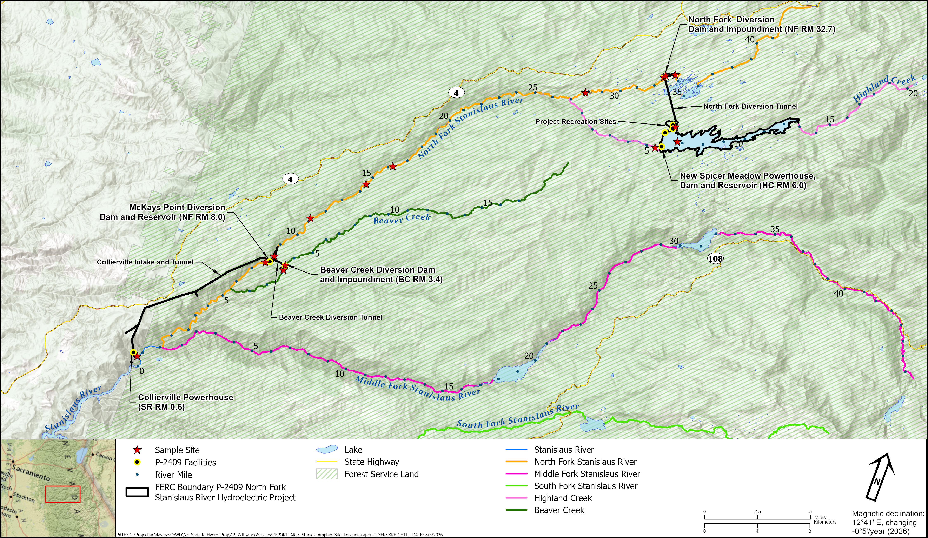
Figure 1. AR-7 Approximate Survey Locations.

Page Left Blank
STUDY METHODS

Field Survey Methods

Field surveys will include visual encounter surveys (VESs) for target species based on aquatic habitat associations and established or recommended methods. Survey methods and frequencies were developed based on available survey guidance, species-specific recommendations, and the information needs of the relicensing process. The proposed surveys are intended to characterize the presence, distribution, habitat use, and life-stages of target species within the Study Area and provide information sufficient to support an analysis of Project-related effects. The study is not intended to satisfy all species-specific occupancy determination protocols or presence/absence survey requirements that may apply in other contexts. Appropriate scientific permitting (e.g., handling permit, scientific collecting permit) for ESA-listed species will be sought from the U.S. Fish and Wildlife Service (USFWS) and California Department of Fish and Wildlife (CDFW) prior to initiating surveys.

For all target species except Yosemite toad, surveyors will conduct a total of three VESs at the survey locations included in Table 1. For Yosemite toad, a single spring survey will be conducted because breeding is concentrated within a relatively narrow seasonal window; a spring survey during suitable breeding conditions is the most effective period for detecting adults, egg masses, and/or larvae. Exact timing for each survey will be determined based on the target species’ breeding seasons and environmental conditions (e.g., snowmelt, temperature, and accessibility) for that year. Surveys for multiple target species may be conducted concurrently based on elevational or target species ranges. For instance, the North Fork Stanislaus River near the Wakalu Hep Yo Campground Area has the potential for four target species (Table 1).

Habitat conditions will be recorded during each survey with notes relevant to each target species, such as habitat type, stream type (i.e., perennial, intermittent, or ephemeral), aquatic and terrestrial vegetation, stream gradient, stream bankfull width estimates, aquatic substrate, water temperature, stream channel characteristics, water clarity, and presence of potential predators. Additionally, during all targeted field surveys, incidental observations of all amphibian or aquatic reptile species will be noted and detailed data will be collected (e.g., location, life stage, habitat description).

Yosemite Toad. The VES will be conducted using survey methods and recommendations for Yosemite toad outlined in Brown et al. (2012 and 2015) and Brown and Olsen (2013). One survey in one calendar year will be conducted, targeting the species’ breeding season when egg masses, tadpoles, and/or breeding adults could be present. It will be timed concurrent with the first Sierra Nevada yellow-legged frog survey.

Foothill Yellow-legged Frog. VESs will be conducted using survey methods and recommendations for foothill yellow-legged frogs outlined in Peek et al. (2017). Three surveys will be conducted in one calendar year between early spring and early fall to target and document all life stages of the species: adults, subadults, tadpoles, and egg masses.

California Red-legged Frog. VESs will be conducted following daytime and, where feasible, nighttime survey methods and recommendations described in USFWS (2005). Three daytime surveys will be conducted at sites with suitable habitat, with survey timing aligned with foothill yellow-legged frog and northwestern pond turtle surveys to the extent practicable. During the daytime survey, surveyors will assess if the site can be feasibly surveyed at nighttime as well (e.g., safely surveyable based on terrain, access, and water safety). If it is deemed feasible, up to three nighttime surveys will be conducted following the daytime survey.

Sierra Nevada Yellow-legged Frog. VESs will be conducted following survey methods and recommendations for Sierra Nevada yellow-legged frogs outlined in CDFW (2022) and using techniques described in Brown and Olsen (2013), Brown et al. (2014), and Brown et al. (2019). Three surveys will be conducted in one calendar year between early spring and early fall (an early-, mid-, and late-season survey) to target and document all life stages of the species and to document presence of the species in and near Project-affected reservoirs and reaches.

Northwestern Pond Turtle. Methods of surveying for this species in lentic and lotic habitats will follow visual survey methods (i.e., pedestrian surveys) and recommendations for pond turtles outlined in USGS (2006) and Bury et al. (2012). Three surveys will be conducted concurrently with surveys for Sierra Nevada yellow-legged frog (where species’ range overlaps), California red-legged frog, and/or foothill yellow-legged frog at sites with suitable aquatic habitat.

Analysis

Species presence and distribution data will be tabulated, summarized, and checked for quality. Habitat conditions, photographs, and other field notes collected during VESs will be used to identify suitable habitat for target ESA-listed amphibian and reptile species within the proposed FERC Project Boundary or potentially affected by the Project.

Occupancy status for Yosemite toad and Sierra Nevada yellow-legged frog will be evaluated using the guidelines outlined in U.S. Department of Agriculture, Forest Service (Forest Service) and USFWS (2014 and 2017) Programmatic Biological Opinions (PBOs), where applicable. These PBOs provide relevant guidelines for evaluating survey data and habitat use for Yosemite toad and Sierra Nevada yellow-legged frog on National Forest System lands and will be used to inform interpretation of survey results, where applicable. If prior surveys have been conducted within the previous ten years, those data will be evaluated in conjunction with results of this Study to determine if there is sufficient data to support a suitability and occupancy determination (e.g., unsuitable or suitable habitat—utilized, utilization unknown, or unutilized potential; USFWS 2017) to support the Project effects analysis.

REPORTING

CCWD will analyze the results of desktop and field efforts as described above. Study data will be made available to interested parties and standard GIS shapefiles, including metadata, if developed will be provided.

SCHEDULE

CCWD anticipates the schedule for Study completion as follows:
Desktop breeding habitat assessment for Yosemite toad December 2026–February 2027
Field surveys for target species March/April–October 2027
Analysis October–December 2027
Reporting December 2027–February 2028

REFERENCES
Bury, R.B., H.H. Welsh, D. J. Germano, D.T. Ashton. 2012. Western pond turtle: Biology, sampling techniques, inventory and monitoring, conservation, and management. Northwest Fauna 7.
Brown, C., K. Kiehl, L. Wilkinson. 2012. Advantages of long-term, multi-scale monitoring: assessing the current status of the Yosemite toad (Anaxyrus [Bufo] canorus) in the Sierra Nevada, California, USA. Herpetological Conservation and Biology, 7, 115–131.
Brown, C. and A.R. Olsen. 2013. Bioregional monitoring design and occupancy estimation for two Sierra Nevadan amphibian taxa. Freshwater Science, 32, 675–691.
Brown, C., L.R. Wilkinson, and K.B. Kiehl. 2014. Comparing the status of two sympatric amphibians in the Sierra Nevada, California: Insights on ecological risk and monitoring common species. Journal of Herpetology, 48, 74–83.
Brown, C., M.P. Hayes, G.A. Green, and D.C. Macfarlane (Tech. Coords.). 2015. Yosemite toad conservation assessment (Gen. Tech. Rep. R5-TP-040). U.S. Department of Agriculture, Forest Service, Pacific Southwest Region, Vallejo, CA. 122 p.
Brown, C., L.R. Wilkinson, K.K. Wilkinson, T. Tunstall, R. Foote, B.D. Todd, and V.T. Vredenburg. 2019. Demography, habitat, and movements of the Sierra Nevada yellow-legged frog (Rana sierrae) in streams. Copeia, 107 (4), 661-675.
CDFW (California Department of Fish and Wildlife). 2022. Protocol for Amphibian and Reptile Visual Encounter Surveys at Monitoring Sites. Version 4. Updated Spring 2022 by I. Chellman.
Forest Service and USFWS (U.S. Department of Agriculture, Forest Service and U.S. Fish and Wildlife Service). 2014. Programmatic Biological Opinion for Yosemite toad, Sierra Nevada yellow-legged frog, and mountain yellow-legged frog—December 19, 2014 (FF08ESMF00-2014-F-0557).
Forest Service and USFWS. 2017. Programmatic Biological Opinion for Yosemite toad, Sierra Nevada yellow-legged frog, and mountain yellow-legged frog—December 19, 2014 (FF08ESMF00-2014-F-0557); amended on June 15, 2017 (FF08ESMF00-2014-F-0557-1) for critical habitat.
Liang, Christina T. 2013. Movements and habitat use of Yosemite toads (Anaxyrus (formerly Bufo) canorus) in the Sierra National Forest, California. Journal of Herpetology 47(4):555-564.
Peek, R.A., S.M. Yarnell, and A.J. Lind. 2017. Visual encounter survey protocol for Rana boylii in lotic environments.
USFWS (U.S. Fish and Wildlife Service). 2005. Revised Guidance on Site Assessments and Field Surveys for the California Red-legged Frog. August 2005.
USGS (U.S. Geological Survey). 2006. Western pond turtle (Emys marmorata) visual survey protocol for the south coast ecoregion. U.S. Geological Survey protocol. San Diego, California.

Project affected streams reaches include reaches downstream of project dams or other release points that have the potential to be affected by Project operations or activities, including portions of Highland Creek, North Fork Stanislaus River, Beaver Creek, and Stanislaus River.
For Yosemite toad occupancy determinations, the PBOs require three VESs, over three separate calendar years, during a ten-year period, with at least one survey during a water year where snowpack is ≥80% of normal. For Sierra Nevada yellow-legged frog occupancy determinations, the PBOs require three surveys within a ten-year period (within one season or in separate years) with one survey conducted in a water year where snowpack is ≥80% of normal.
In addition to the details provided in this section, reporting will also follow the "Concepts and Practices Applicable to All Relicensing Studies" developed by CCWD.

