STUDY DESCRIPTION RR-3
Fishing, Swimming and Wading Use Evaluation at Calaveras Big Trees State Park
Draft – 4/20/2026

This Study Description is developed to inform information gaps identified by Calaveras County Water District (CCWD) for the relicensing of its North Fork Stanislaus River Hydroelectric Project (Project).

STUDY AREA

The Study Area includes the North Fork Stanislaus River (NFSR) access sites within Calaveras Big Trees State Park (Big Trees SP) in the vicinity of the bridge over the NFSR along Walter W. Smith Parkway (Figure 1). The Study Area is the 0.3-mile-long section of the North Fork Stanislaus River from River Mile (RM) 11.2 to RM 10.9.





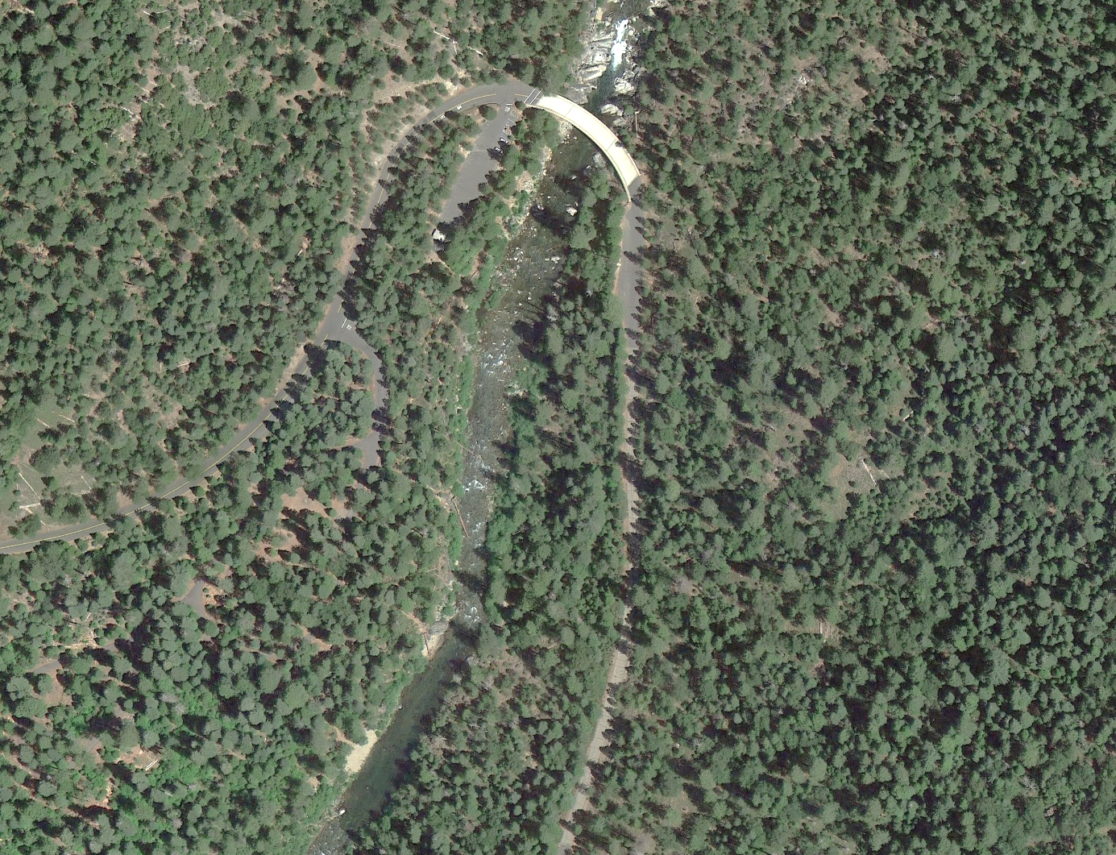
Walter W. Smith Parkway
North Fork Stanislaus River
LEGEND
River Mile #
Parking
Picnic area
10.9
11.2
11.1
11.0
Stanislaus River Access Day Use Area
River Picnic Area
Figure 1. Aerial view of the study area along NFSR within Calaveras Big Trees State Park.
STUDY METHODS

Excluding Data Summary Development (i.e., Reporting), the Study consists of three steps: 1) Gather Information; 2) Conduct Focus Groups; and 3) Summarize River Recreation Opportunities. Each of these steps is detailed below. The goal of the focus groups is to describe the character of angling, swimming, and wading recreation opportunities in the Study Area and identify flow-dependent attributes.

Step 1 – Gather Information
CCWD will coordinate with Big Trees SP staff to:

- Identify popular sites for fishing, swimming, and wading opportunities.
- Identify the river recreation uses (i.e., fishing, swimming, and/or wading) that occur at each site.
- Identify the peak use periods for each use (i.e., fishing, swimming, and wading).

CCWD will photo-document and map the specific river access locations.

CCWD will summarize representative years of the existing NFSR hydrology (average hourly flows) at the USGS gage near Avery, CA (USGS-11294500) at River Mile (RM) 8.8, approximately 2.4 miles downstream of Big Trees SP for the peak recreation use season(s).

Step 2 – Conduct Focus Groups
CCWD, in consultation with Big Trees SP staff and interested participants will select focus group participants. Participants will include river recreationists (i.e., anglers, waders, and swimmers) and State Park staff, at a minimum. Each focus group will consist of no more than 10 participants.

CCWD will conduct up to two focus group meetings – one meeting with anglers and one meeting with swimmers/waders.

Focus Group Process
Focus group topics will likely include: 1) access considerations; 2) flow ranges for each type of opportunity (i.e., angling, wading, swimming); and 3) constraints to each type of use. In addition, the angling focus group will include additional topics such as target species, types of fishing (e.g., wade/boat-based/shore-based, spin/bait/fly), and angling quality.

A second series of questions will focus on the effects of flows on those attributes and whether interviewees can identify specific flows that affect the quality of these opportunities.

Focus groups and interviews will be semi-structured, with specific topic areas and questions developed for anglers and swimmers/waders.

The focus group will include up to two CCWD-provided facilitators. The facilitators will pose open-ended questions to guide discussion but will draw out participants with follow-up questions as needed. The focus groups will be scheduled after CCWD researchers have completed Step 1 to increase opportunities for shared understanding about the locations and issues under discussion.

Step 3 – Summarize River Recreation Opportunities
CCWD will summarize the types of use(s), acceptable flow ranges, and general physical site characteristics at the identified river access locations.

CCWD will describe the following for angling and swimming/wading opportunities, as applicable:

- Existing use types and levels
- River access locations and constraints
- Safety considerations
- Acceptable flow range
- Physical characteristics of river
- Availability of flow information
- “Usable-day” opportunities under existing Project operations within the identified acceptable flow range using the historical flow records for the reaches.
- Representative photographs of each river access location.

REPORTING

CCWD will analyze the data to include summary text, tables, figures, and maps, as applicable and completed focus group summaries. The study data will be provided to interested parties as described in Concepts and Practices Applicable to All Relicensing Studies.

SCHEDULE

Step 1 – Gather Information February - November 2027
Step 2 – Conduct Focus Groups July - October 2027
Step 3 – Summarize Opportunities October - December 2027
Reporting January - March 2028

REFERENCES

None.

In addition to the details provided in this study description, study implementation will also follow the "Concepts and Practices Applicable to All Relicensing Studies" developed by CCWD.
A “usable-day” opportunity is any flow within the acceptable flow range that that is continuously present in the channel during 8 hours of daylight as recorded at the USGS-11294500 gage.

