Table 1. CCWD’s Response to STF’s Request for Additional RR-1 Study Sites. [Refer to Figures 1 through 4 below the table as a visual aid (consistent shading/coloration).]
Item | Location Type | Stanislaus National Forest (STF) Requested RR-1 Study Sites |  | CCWD Response
Item | Location Type | Location | Details | Decision | Rationale
1 | Road | Forest Road 7N29Y | Dirt Road – dispersed camping and wilderness access. Hunting, and access to other roads listed below. Summit Lake TH – to Summit Lake. Elephant Rock TH | Added to RR-1 (partial). | Access: shared use road; used to access No. Fork Diversion Tunnel Outlet Channel facility. CCWD has included the sites off of Forest Road 7N29Y in the vicinity of the Project facility (No. Fork Diversion Tunnel Outlet Channel) and adjacent to the Project campground (New Spicer Meadow Campground). CCWD did not include any sites/areas beyond these sites on Forest Road 7N29Y, which leads away from the Project to non-Project STF areas including Summit Lake, Utica Reservoir, Union Reservoir, and Elephant Rock Trailhead.
2 | Road | Forest Road 7N55Y – dirt road, very rocky/overgrown. Access to Summit Lake and Hobart Creek. | Lots of large group dispersed camping, wilderness, camping, hunting, serves as overflow camping for Spicer and provides access to water access, hiking. | Not included in RR-1. | Access: non-Project road/not used for Project O&M. This forest road and area is not associated with the Project impoundments and provides access to recreation in the STF for land-based uses (not reservoir-based uses).
3 | Trail | Forest Road 7N01 – TH to Wheats Meadow | 18E04 trail that leads into wilderness  19E05 follows wilderness boundary, creek crossing and connects to 20E02 and other connectors adjacent to the lake and wilderness access. | Not included in RR-1. | Access: non-Project trail/not used for Project O&M. The trails from the trailhead at the end of Forest Road 7N01 do not connect Project facilities. Rather, these trails lead into broader STF areas, the Carson-Iceberg Wilderness, and other non-Project trails throughout the STF and Carson-Iceberg Wilderness.
4 | Site | Site below Spicer Dam (end of Forest Road 7N01) | Picnic area next to bridge. Area is used for dispersed camping, day use, water access. Trail access, Spicer ledger (rock climbing) bolted routes. | Not included in RR-1. | Access: shared use road/used to access Spicer Dam/Powerhouse facilities for Project O&M. This site provides access to non-Project areas and land-based uses (not Project reservoir-based uses) in the STF and Carson-Iceberg Wilderness to the south, west, and east of New Spicer Meadow Reservoir. See response to Item #3 and #5.
5 | Site | Spicer picnic area is just north of Spicer Dam | Day-use picnicking | Included in RR-1. | Access: shared use road/used to access New Spicer Meadow Reservoir recreation facilities, shoreline and dam/powerhouse facilities for Project O&M. CCWD is not aware of a formal picnic area facility north of the dam. CCWD assumes the STF is referring to the undeveloped shoreline access site(s) just north of New Spicer Meadow Dam. If so, then CCWD has already included as study sites in RR-1 the five (5) pullouts (4 paved and 1 gravel/dirt) along the 0.5-mile stretch of Spicer Reservoir Road that provide undeveloped shoreline access to New Spicer Reservoir between the New Spicer Meadow Group Campground and the right abutment of New Spicer Meadow Dam (as these locations provide direct access to the Project reservoir for shoreline day-use and water-based activities).
6 | Trail | Forest Trail 18E05 - TH also connector at Spicer Reservoir Road (Forest Road 7N01) | Trail leads to multiple connections; dispersed camping | Not included in RR-1. | Access: non-Project trail/not used for Project O&M. This trail provides access to non-Project areas and land-based uses (not Project reservoir-based uses) south and west of Spicer Reservoir Road and leads to the Sandy Flat/Wolfboro area of the NFSR (approx. 5 miles west of Spicer Reservoir Road and New Spicer Meadow Reservoir).
7 | Road | Forest Road 6N29Y | Dispersed recreation, area used by camping and hunting, mtn biking, hiking | Not included in RR-1. | Access: non-Project road/not used for Project O&M. This road provides access to non-Project areas and land-based uses (not Project reservoir-based uses) south of Spicer Reservoir Road and connects to Forest Trail 18E05 that leads to the Sandy Flat/Wolfboro area of the NFSR (approx. 5 miles west of Spicer Reservoir Road and New Spicer Meadow Reservoir).
8 | Trail | Forest Trail 18EV295 |  | Clarification Needed. | CCWD is unsure where this trail is located as it did not show up on the STF’s Motor Vehicle Use Maps (it was included in trail table but not on the map itself).
9 | Site/Road | North Fork Diversion Dam & Impoundment (Forest Road 7N17 and 7N17B) | 18EV536 Access at Dam – Recreation includes camping, OHV use, fishing, Mtn Biking, dispersed camping-target shooting | Added to RR-1 (partial). | Access: shared use road (7N17), Project road (7N17B)/used to access No. Fork Diversion Dam for Project O&M. CCWD has included the Project impoundment as a RR-1 study site, where CCWD will collect vehicle observation and visitor surveys. Of note, CCWD will visit the site and observe if any vehicles are parked at the gate leading to the North Fork Diversion Dam. CCWD will conduct an observation survey, and if a vehicle(s) is parked at the gate, then CCWD will walk to impoundment to see if visitors available for visitor survey. If no vehicles are observed in the vicinity of the gate, then CCWD will not travel by foot to the impoundment to search for visitors. Note that this broader area includes the STF’s Slick Rock OHV Trailhead. CCWD does not intend to collect observation or visitor survey information associated with this non-Project recreation trailhead and trail, which leads away from the North Fork Diversion Dam to the north terminating at Highway 4.
10 | Site | Beaver Creek Diversion Dam | Day Use, fishing, hunting, dispersed camping in area | Added to RR-1. | Access: Project road/facility/used for Project O&M. CCWD will conduct observation and visitor surveys at this Project impoundment (Beaver Creek Diversion Impoundment) but with a reduced frequency of visitation. CCWD will visit Beaver Creek Diversion Impoundment on one (1) weekday and one (1) weekend day per month in June, July, and August (6 days total), plus one (1) holiday weekend day during each of the summer holiday weekends (Memorial Day, Independency Day, and Labor Day) (3 days total) -- for a total of nine (9) sampling days. CCWD believes this reduced sampling frequency is warranted given the low recreation use that occurs at this small, remote impoundment while still allowing CCWD to adequately characterize the Project recreation use.
11 | Road | Spicer Reservoir Road, Forest Road 7N77 | Dispersed camping and hunting | Not included in RR-1. | Access: non-Project road/not used for Project O&M. This road/dispersed use area on the STF is located approximately 3.5 miles from the nearest Project facility (New Spicer Meadow Reservoir) off Spicer Reservoir Road. This road/area provides access to multiple, non-Project uses and areas and dead ends in the STF.
12 | Road | Spicer Reservoir Road (Forest Road 7N01) - Bloods Creek | Dispersed camping | Not included in RR-1. | Access: non-Project road/not used for Project O&M. This dispersed use area on the STF is located approximately 7 miles from the nearest Project facility (New Spicer Meadow Reservoir) off Spicer Reservoir Road on Forest Road 7N01C. This road/area provides access to multiple, non-Project uses and areas in the midst of the STF.
13 | Site | Stanislaus River Campground and Crossing | Large, dispersed area. Camping, target shooting, fishing, hiking, area is highly affected by the abundance of visitors. Developed CG would benefit from improvements, and expanded facilities in the area. | Not included in RR-1. | Access: shared use road/used for access to Project facilities in the area for Project O&M. The STF’s Stanislaus River Campground and crossing area is located approximately 6 miles from the nearest Project facility (New Spicer Meadow Reservoir) along Spicer Reservoir Road. This site/area provides access to multiple, non-Project uses and areas.
14 | Site | Spicer Reservoir Road (Forest Road 7N01H) at Highway 4 - Recreation | Sno-Park – snow play, snowmobiling, grooming. OHV Area during summer months. | Not included in RR-1. | Access: non-Project road/not used for Project O&M. Spicer Sno-Park, located immediately off Highway 4 and Spicer Reservoir Road on Forest Road 7N01H, is approximately 9 miles from the nearest Project facility (New Spicer Meadow Reservoir). Further, the site provides for non-Project, non-reservoir, winter-based recreational uses (e.g., cross-country skiing, dog sledding, snow play, snowmobiling, and non-Project summer uses (OHV), and provides access for these uses throughout the STF in this area.
15 | Road | Spicer Reservoir Road (Forest Road 7N01) from Highway 4 - Spicer | Entire road has multiple dispersed sites for multi recreation opportunities. | Included in RR-1 (partial). | Access: shared use road/used for access to Project facilities in the area for Project O&M. CCWD has already included as study sites in RR-1 the five (5) pullouts (4 paved and 1 gravel/dirt) along the 0.5-mile stretch of Spicer Reservoir Road that provide undeveloped shoreline access to New Spicer Reservoir between the New Spicer Meadow Group Campground and the right abutment of New Spicer Meadow Dam (as these locations provide direct access to the Project reservoir for shoreline day-use and water-based activities). See response to Item #5.  Spicer Reservoir Road is a multi-use road and the areas off this road along the first 9 miles of Spicer Reservoir Road starting at Highway 4 are for non-Project uses not associated with New Spicer Meadow Reservoir or other Project impoundments/facilities in this area. As such, this stretch of Spicer Reservoir Road will not be included in RR-1. The first approximately 9 miles of Spicer Reservoir Road provides access to a broad array of non-Project sites, trails, roads, and areas throughout the STF, including the non-Project Utica and Union Reservoirs, which provide numerous non-Project recreation facilities and opportunities.
16 | Road | Forest Road 7N49Y and 7N38 | Dispersed Camping, OHV use, hunters, target shooting | Not included in RR-1. | Access: non-Project road/not used for Project O&M. These roads provide access to non-Project areas and land-based uses (not Project reservoir-based uses) west and north of Spicer Reservoir Road and New Spicer Meadow Reservoir. This forest road provides access to NCPA’s Utica and Union Reservoirs.

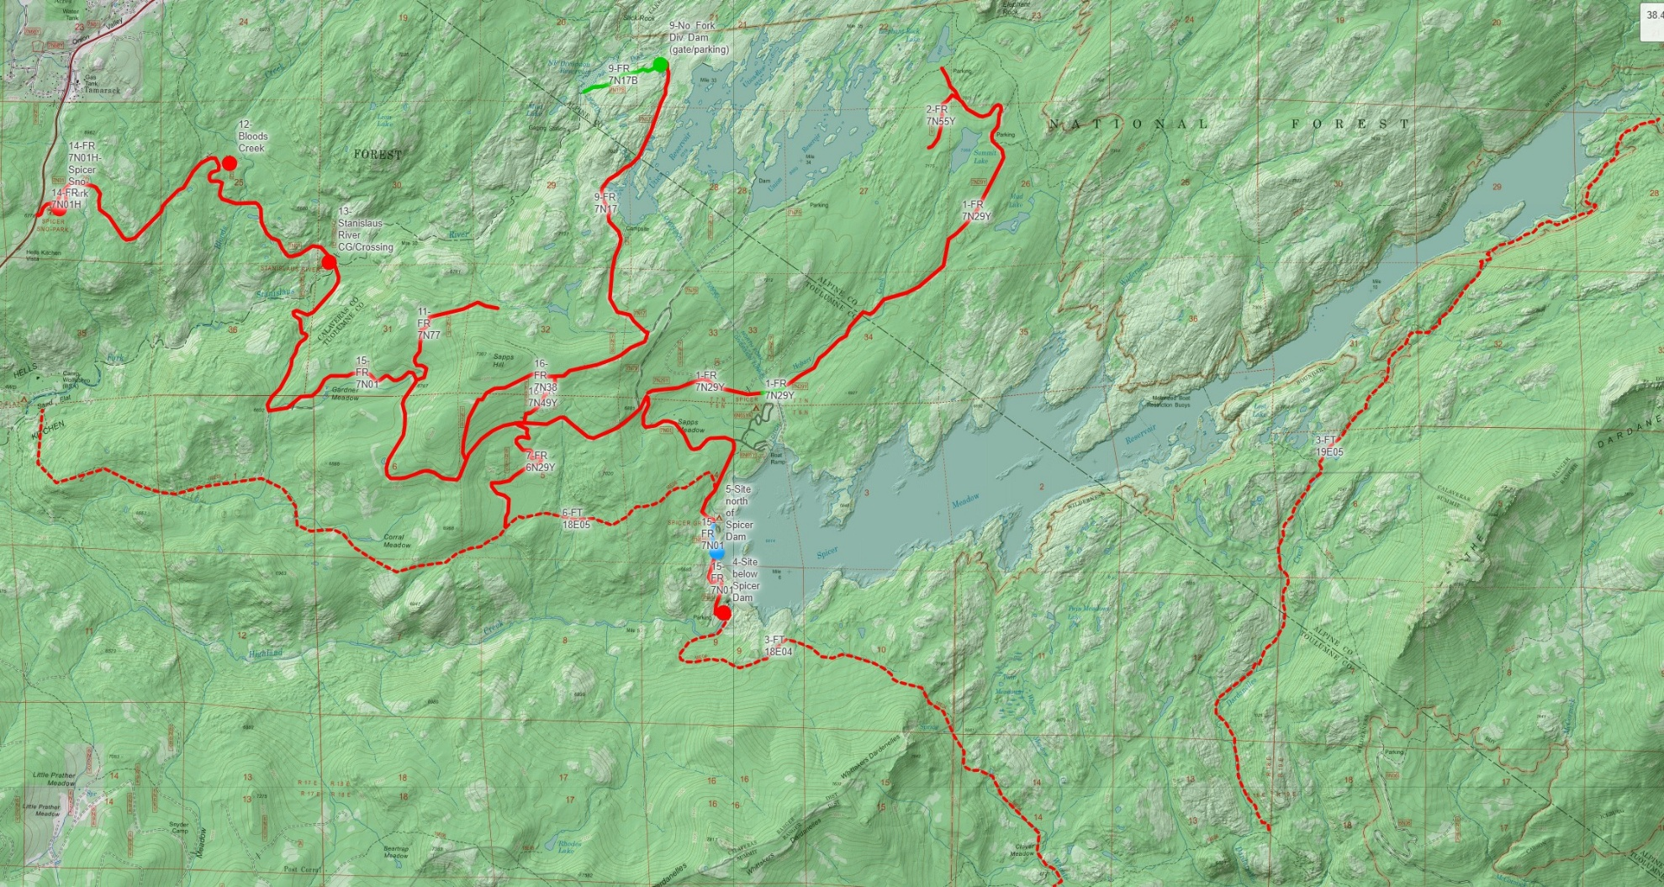
Figure 1. RR-1: Recreation Use & Surveys: Map of STF-requested study site additions - Overview.

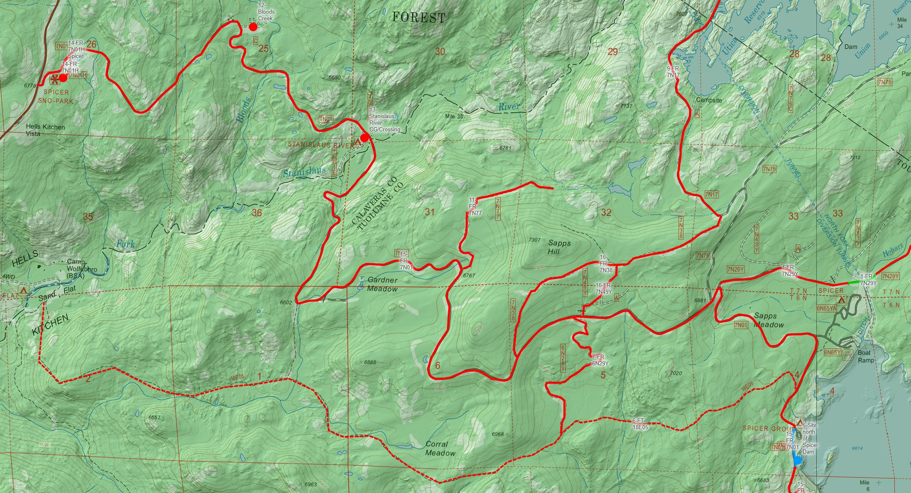
Figure 2. RR-1: Recreation Use & Surveys: Map of STF-requested study site additions - Spicer Reservoir Road (FR 7N01).

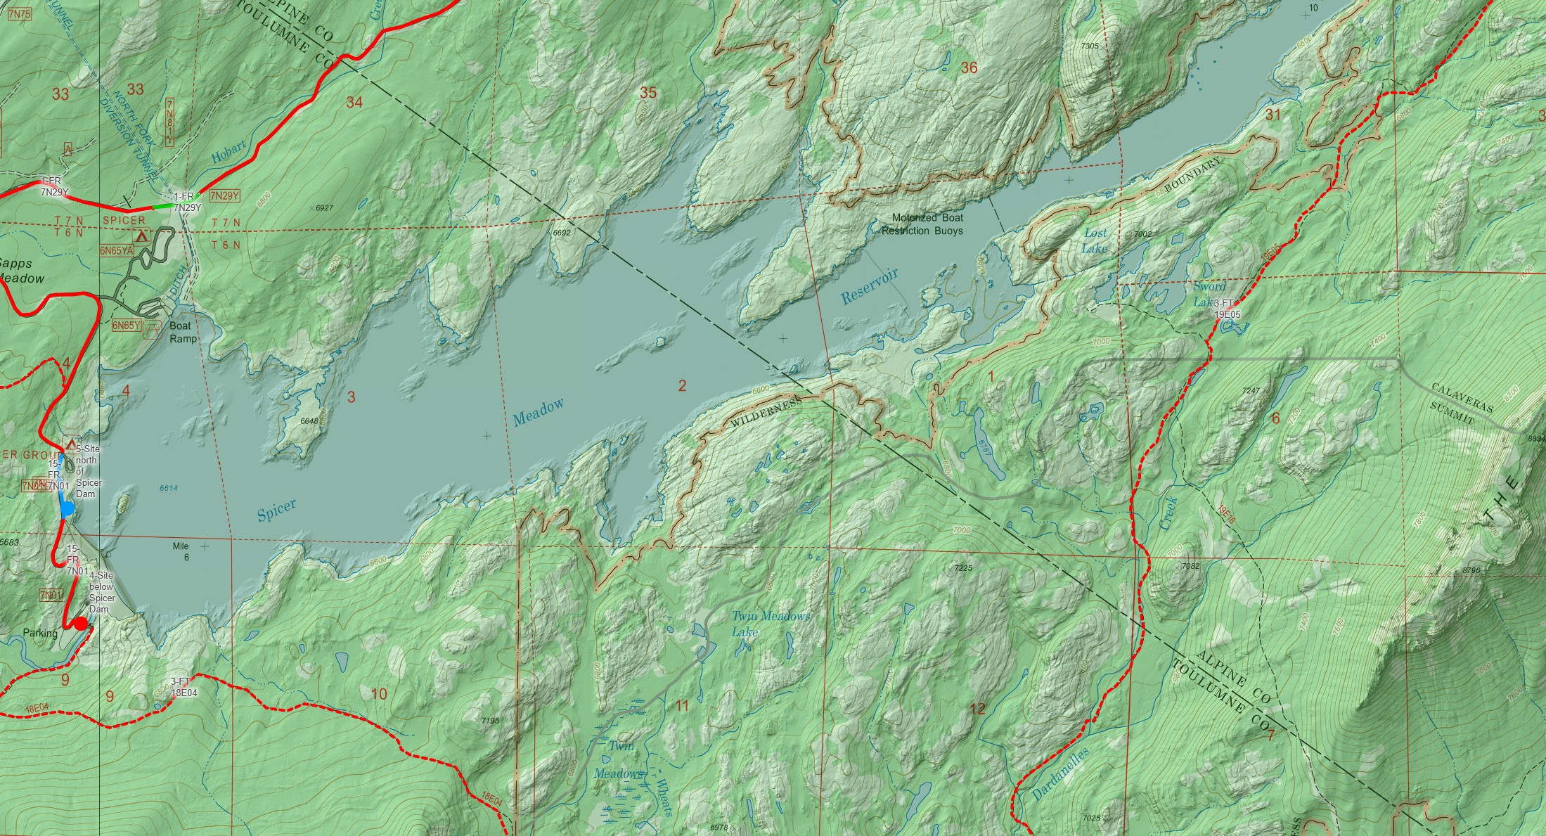
Figure 3. RR-1: Recreation Use & Surveys: Map of STF-requested study site additions - Spicer Reservoir area.

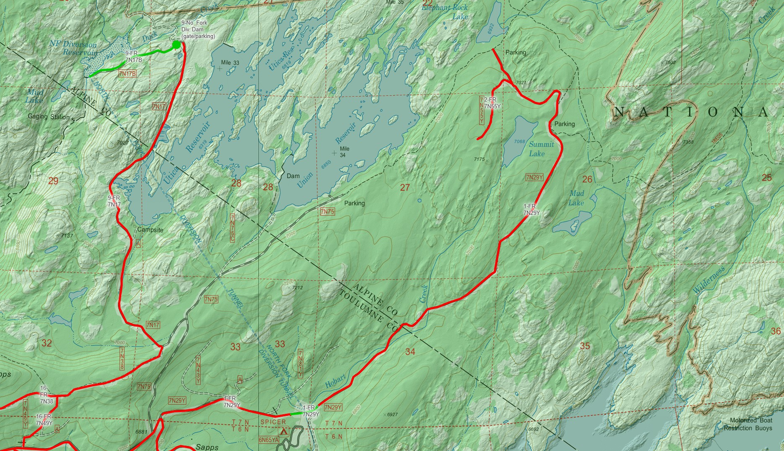
Figure 4. RR-1: Recreation Use & Surveys: Map of STF-requested study site additions - North Fork Diversion Dam/Utica-Union Reservoirs area.

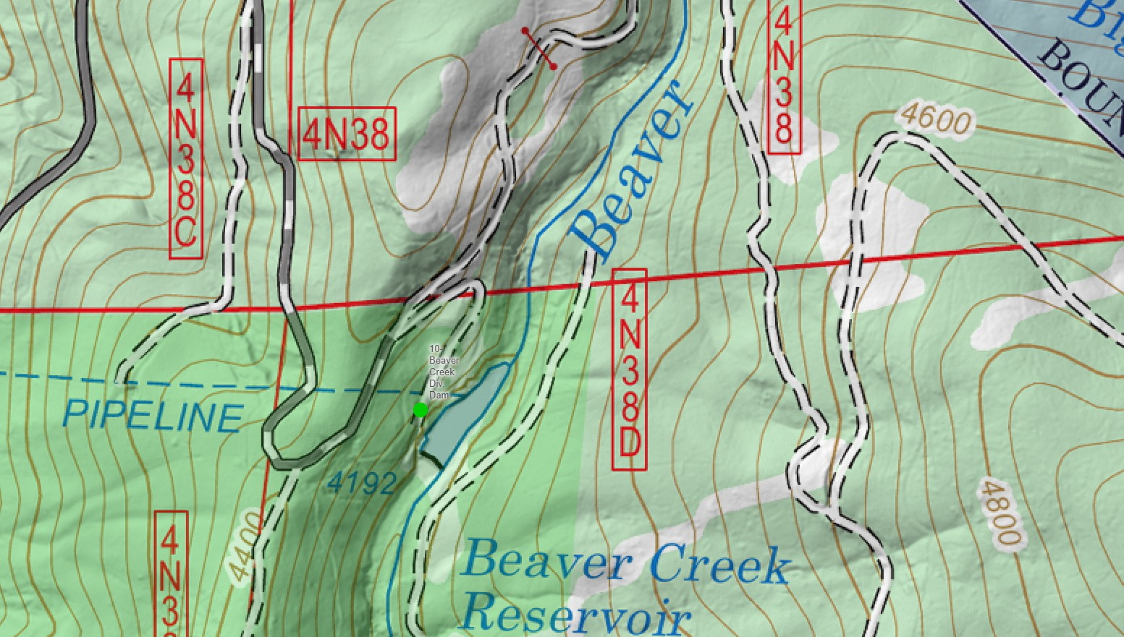
Figure 5. RR-1: Recreation Use & Surveys: Map of STF-requested study site additions - Beaver Creek Diversion Dam.

