STUDY DESCRIPTION AR-1
Fish Sampling in New Spicer Meadow Reservoir
Draft – May 2026

This Study Description was developed to inform information gaps identified by Calaveras County Water District (CCWD) for the relicensing of its North Fork Stanislaus River Hydroelectric Project (Project).

STUDY AREA

The Study Area includes the western half of New Spicer Meadow Reservoir (Figure 1).

Sampling Sites

General sampling sites are identified in Figure 1. Because of the motorized boat restrictions in the eastern portion of the reservoir associated with the Carson-Iceberg Wilderness Area (Forest Service 2026), CCWD selected sites in the western half of the reservoir where access is more feasible for sampling. Given this restriction, sampling sites were selected to distribute sampling across the western half of the reservoir and target multiple habitat types.
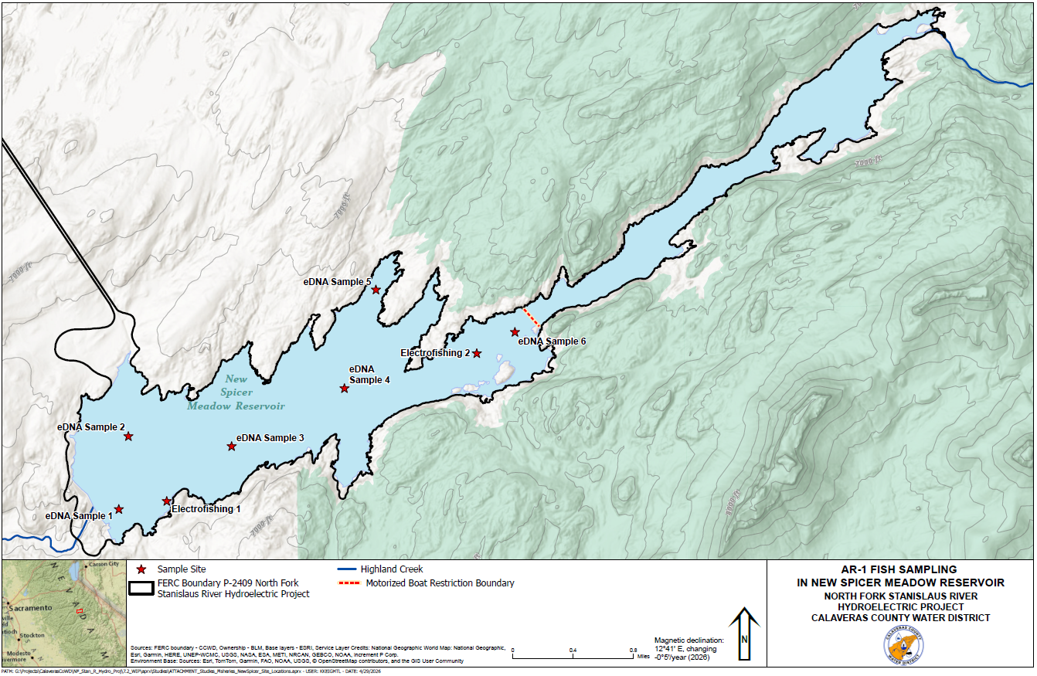

Figure 1. North Fork Stanislaus River Hydroelectric Project AR-1 Sampling Sites. Note that the identified motorized boat restriction boundary limits access to the eastern half of the reservoir.
STUDY METHODS

Field Methods

Fish sampling will be conducted at New Spicer Meadow Reservoir once during summer 2027 using a combination of eDNA and boat electrofishing. In general, eDNA will be used to sample more broadly for species composition and in deeper habitats and boat electrofishing will be used to sample shoreline habitats and individual fish data. An eDNA-based approach is an efficient, non-invasive method to detect fish species present in the reservoir by analyzing organisms’ DNA shed into the water column, providing a comprehensive assessment of fish species present over time from a reduced number of field samples. This study is conditional on measures contained within the California Department of Fish and Wildlife (CDFW) scientific collecting permit and USFWS 10(a)1(a) permit, which will be obtained prior to sampling. Study methods described below that are unsupported by permits may not be implemented.

General information recorded at each sampling location will include site name, sampling method, GPS coordinates of sample location, weather conditions including air temperature, incidental habitat observations, minimum, mean, and maximum depth, and in situ water chemistry (e.g., water temperature, dissolved oxygen, pH, and conductivity).

eDNA Sampling

eDNA samples will be obtained at six locations following Genidaqs standard protocols and using designated sampling kits for eDNA metabarcoding (simultaneous multi-species eDNA detection). Detailed protocols and methods are provided in Attachment A.

Due to lake stratification, eDNA samples will be collected above and below a thermocline at each sampling site to maximize species detection and improve spatial representation of the fish community. Thermocline depth will be identified in situ using a cabled water quality meter prior to sample collection. Sampling across stratified layers increases the likelihood of detecting species that may occupy distinct vertical habitats within the reservoir.

Boat Electrofishing

Two sampling sites will be identified in New Spicer Meadow Reservoir in the field (Figure 1). Locations will be selected to distribute sampling spatially and survey across multiple habitat types. Boat electrofishing using standard methods (Reynolds 1996) to sample nearshore habitat will be conducted to supplement eDNA collection. Sampling will occur primarily in the daytime and will encompass dawn and/or dusk hours. Voltage settings will be generally between 350 and 450 volts, depending on water conductivity and water temperature. Electrofishing stations will be approximately 150 feet in length and will target a diversity of nearshore habitats. Sampling will begin at one end of a station with the boat perpendicular to shore about 30 feet out from the shoreline or zone too shallow to operate the boat. This area will be electrofished toward shore until the electrodes touch the shoreline, or in stations with shallow depths, to prevent boat damage. In stations with downed trees, sampling will proceed until the electrodes touch the woody vegetation. The boat will be backed away from shore and maneuvered parallel to the shoreline approximately 10 to 15 feet from the previous area, and electrofishing will proceed in this manner until the entire station is sampled. Electrofisher “time-on” will be recorded for each sampling site, and a consistent pace and effort will be employed at all sites.

Captured fish will be enumerated, identified to species, measured to fork length, and the first 20 individuals of each species will be weighed in each sampling site. Trout origin will be identified (hatchery or wild stock) based on adipose fin clips. Captured fish will be allowed to recover after processing and will be released at the site after the sampling is complete or in an area away from sampling.

Analysis

Data summary will include quantifying and describing species composition, distribution, and relative abundance as available. General information for each site will be presented including site name, sampling method, GPS coordinates of sample location, weather conditions including air temperature, incidental habitat observations, minimum, mean, and maximum depth, and in situ water chemistry (e.g., water temperature, dissolved oxygen, pH, and conductivity).

eDNA Sampling

Results of the eDNA metabarcoding analysis will be provided by Genidaqs. This will include a list of species detected, along with supporting tables and figures, as applicable. Fish species composition and distribution information will be compared to known species information as presented in Section 3.4 of the Pre-Application Document.

Boat Electrofishing

Data collected during the fish surveys will be entered into an Excel database for data reduction, tabulation, and summary. Fish capture will be reported both as total catch and in terms of catch per unit effort (CPUE). CPUE for fishes captured by electrofishing will be calculated by dividing the number of fish of each species captured by the total area of water sampled multiplied by the length of time fished [e.g., fish/ (ft² x second)].

CPUE will be summarized by location and species. Fish species composition and distribution information will be compared to known species information as presented in Section 3.4 of the Pre-Application Document.

Data summary will include quantifying and describing species composition, distribution, and relative abundance. Length-weight regression plots will be developed for all species using length and weight measurements. Additionally, Fulton’s condition factor (Ricker 1975) for salmonids will be calculated using length and weight measurements. Length frequency histograms by species will also be developed.

REPORTING

This Study will generate the tables and plots described above related to site habitat information, eDNA analysis results, and electrofishing (e.g., CPUE, species composition, fish metrics, etc.).

SCHEDULE

CCWD anticipates the schedule for Study completion as follows:

Conduct Field Sampling June – September 2027
Data Analysis and Reporting September 2027 – December 2027

REFERENCES

Reynolds, J.B. 1996. Electrofishing. Pages 221–254 in B.R. Murphy and D.W. Willis, editors. Fisheries techniques, 2nd edition. American Fisheries Society, Bethesda, Maryland.

Ricker, W.E. 1975. Computation and interpretation of biological statistics of fish populations. Fisheries Research Board of Canada. Bulletin 191. Available online at: https://waves-vagues.dfo-mpo.gc.ca/Library/1485.pdf. Accessed on March 24, 2026.

USFS (United States Department of Agriculture, Forest Service). 2026. Carson-Iceberg Wilderness Map. Stanislaus National Forest. Available online at: https://www.fs.usda.gov/sites/nfs/files/r05/stanislaus/publication/carson-iceberg-wilderness-map.pdf . Accessed on March 20, 2026.

In addition to the details provided in this study description, study implementation will also follow the "Concepts and Practices Applicable to All Relicensing Studies" developed by CCWD.
Dawn and/or dusk timing will be determined by the field crew leader based on local sunrise/sunset timing on the actual date of sampling.
In addition to the details provided in this section, reporting will also follow the "Concepts and Practices Applicable to All Relicensing Studies" developed by CCWD.

